**EE175AB Final Report**

**Smart Plugs**

**EE 175AB Final Report**

**Department of Electrical Engineering, UC Riverside**

| **Project Team Member(s)** | Zhuocheng Hu, Yaoteng Tan, Zhengxuan Wen |
| --- | --- |
| **Date Submitted** | March 12, 2022 |
| **Section  Professor** | Dr. Roman Chomko |
| **Revision** | Revision 1.0 |
| **URL of Project YouTube Videos, Wiki/Webpage** | <https://youtu.be/_FVOdcHLb0E> |
| **Permanent Emails of all team members** | [zhu026@ucr.edu](mailto:zhu026@ucr.edu) (Zhuocheng Hu)  [ytan073@ucr.edu](mailto:ytan073@ucr.edu) (Yaoteng Tan)  [zwen003@ucr.edu](mailto:zwen003@ucr.edu) (Zhengxuan Wen) |

**Summary**

This report presents the design and development of a system of smart plugs. The content within the document illustrates the details regarding the project.

#### Revisions

| **Version** | **Description of Version** | **Author(s)** | **Date Completed** | **Approval** |
| --- | --- | --- | --- | --- |
| 0.1 | Started drafting | Zhuocheng Hu,  Yaoteng Tan,  Zhengxuan Wen | 02/22/2022 |  |
| 0.2 | First draft | Zhuocheng Hu,  Yaoteng Tan,  Zhengxuan Wen | 03/05/2022 |  |
| 1.0 | Final draft | Zhuocheng Hu,  Yaoteng Tan,  Zhengxuan Wen | 03/12/2022 |  |

#### Table of Contents

**Revisions 2**

**Table of Contents 3**

**1 Executive Summary 6**

**2 Introduction 7**

2.1 Design Objectives and System Overview 7

2.2 Backgrounds and Prior Art 7

2.3 Development Environment and Tools 9

2.4 Related Documents and Supporting Materials 9

2.5 Definitions and Acronyms 10

**3 Design Considerations 11**

3.1 Realistic Constraints 11

3.2 System Environment and External Interfaces 11

3.3 Industry Standards 12

3.4 Knowledge and Skills 12

3.5 Budget and Cost Analysis 13

3.6 Safety 13

3.7 Performance, Security, Quality, Reliability, Aesthetics etc. 14

3.7 Documentation 14

3.9 Risks and Volatile Areas 14

**4 Experiment Design and Feasibility Study 15**

4.1 Experiment Design 15

4.2 Experiment Results, Data Analysis and Feasibility 17

**5 Architecture and High Level Design** **20**

5.1 System Architecture and Design 20

5.2 Hardware Architecture 21

5.3 Software Architecture 24

5.4 Rationale and Alternatives 30

**6 Data Structures** **32**

6.1 Internal software data structure 32

6.2 Global data structure 32

6.3 Temporary data structure 32

6.4 Database descriptions 32

**7 Low Level Design** **33**

7.1 Socket - Hardware 33

*7.1.1 Processing narrative for Socket - Hardware* *36*

*7.1.2 Socket - Hardware interface description* *36*

*7.1.3 Socket - Hardware processing details* *36*

7.2 Remote controller - Hardware 38

*7.2.1 Processing narrative for Remote controller - Hardware 40*

*7.2.2 Remote controller - Hardware interface description 40*

*7.2.3 Remote controller - Hardware processing details 41*

7.3 Socket - Software 41

*7.3.1 Processing narrative for Socket - Software 42*

*7.3.2 Socket - Software interface description 42*

*7.3.3 Socket - Software processing details 42*

7.4 Remote controller - Software 43

*7.4.1 Processing narrative for Remote controller - Software 43*

*7.4.2 Remote controller - Software interface description 44*

*7.4.3 Remote controller - Software processing details 44*

7.5 Connectivity App - Software 44

*7.5.1 Processing narrative for Connectivity App - Software 44*

*7.5.2 Connectivity App - Software interface description 45*

*7.5.3 Connectivity App - Software processing details 45*

**8 Technical Problem Solving** **46**

8.1 The PCB Design Problem 46

8.2 Solving The PCB Design Problem 46

8.3 The Keil Compiling Problem 46

8.4 Solving The Keil Compiling Problem 46

**9 User Interface Design** **47**

9.1 Application Control 47

9.2 User Interface Screens 47

**10 Test Plan** **49**

10.1 Test Design 49

10.2 Bug Tracking 53

10.3 Quality Control 54

10.4 Identification of critical components 54

10.5 Items Not Tested by the Experiments 54

**11 Test Report** **55**

11.1 Test 1 55

11.2 Test 2 56

11.2 Test 3 57

11.2 Test 4 58

11.2 Test 5 59

**12 Conclusion and Future Work 61**

12.1 Conclusion 61

12.2 Future Work 62

12.3 Acknowledgement 62

**13 References** **64**

**14 Appendices** **65**

# Executive Summary

The 21st century is called the age of information technology. With the rapid growth of technologies, people are actively developing and employing high-tech products that can change their way of living. Under these circumstances, the project of smart plugs arises. The system can serve both personal and commercial purposes. The goal of the project is to design and develop an open-source and low-cost smart plugs system that can benefit the world societally, environmentally, and economically.

In summary, when using the system, users will be able to better control and monitor the electric appliances in a convenient way. The project consists of two general parts - the hardware and the software. The hardware part includes multiple sockets and a remote controller. The design of the project comes from scratch. The design of the system includes PCB design and integrating various micro control units with other electronic components, all through the professional and industrial software of Altium. On the other hand, the software part includes the programming of the micro control units, the Android app, and the server. Same as the hardware, professional software and tools such as Keil MDK-ARM and Eclipse IDE involve in the process. We are able to program the micro control units and the Android app to accomplish the desired functions. Furthermore, we adopt new technologies such as the LoRa, which is a proprietary low-power wide-area network modulation technique, to extend and enhance the functionality of our project.

By combining the hardware and software together, the project has many excellent key features. Thanks to the LoRa, we greatly extend the control range of the remote controller compared to those using traditional Bluetooth and IR techniques. What’s even better, users are able to use this feature without Internet connections, such as Wi-Fi or 4G/5G. It makes our project broadly applicable. Furthermore, by using the server and phone app, the users can control the sockets and monitor their status from everywhere from the world as long as they have Internet connections. All these features promote a high-tech society, help manage power resources more efficiently and eventually benefit the environment and economy.

To conclude, we accomplished an important and useful senior design project and successfully achieved our design objectives. It incorporates many areas of electrical engineering, such as circuit designs, embedded systems, and software development. During the project, we learn how to use brand-new hardware and software. We enjoy the project in that we are able to draw inspiration from existing products in the market, redesign from the start and merge innovation and new technologies into it.

# Introduction

## Design Objectives and System Overview

The objective of the project is to design a wall plug system that is capable of reporting its status and being controlled through multiple ways. The system incorporates many areas of electrical engineering, such as circuit designs, embedded systems, and software development.

The overall goal is to design and develop an open-source and low-cost smart plugs system that can benefit the world societally, environmentally, and economically. The expectation is to help the users to gain better control of the electric appliances and save electricity costs if necessary. The project promotes societal, environmental, and economic benefits.

The system targets both personal and commercial users. For personal users, the intended application is to work as a part of the “smart home” concept, which is a home equipped with electronic devices that can be controlled remotely. For commercial users, the system is intended to be used to systematically control electronic devices in working spaces. Thanks to the LoRa and Internet connections, the system is suitable for use in both urban and rural areas.

The system includes 2 sockets, 1 remote controller, 1 cloud server, and 1 Android app. The users can control the sockets through both the remote controller and the Android app. At the same time, all of the sockets, the remote controller, and the Android app synchronize with each other and report the status of the sockets back to the users.

The system follows the following quantitative technical design objectives. The sockets have an input of 120V 60Hz AC power supply and an output of 120V 60Hz power supply. The remote controller has an input of a 5V DC power supply. Solely using the sockets and the remote controller, the users are able to control the sockets and monitor their status within an ideal range - up to 0.5 miles (about 0.80 kilometers) in urban areas and up to 3 miles (about 4.8 kilometers) or more in rural areas (line of sight). The delay of the input of commands and output of status is from 300 ms to 1000 ms based on the distance between the LoRa modules. When using the Android app to control the sockets, the control range is extended to unlimited as long as the sockets and the Android app are connected to the Internet. The input delay (to turn on the sockets) is less than 150 ms and the output delay (for the system to report status back to the app) is less than 2000ms under normal Internet conditions.

In the project, responsibilities of the work follow as below*:

Zhuocheng Hu - hardware design and development, server research and development

Yaoteng Tan - software development of remote controller(STM32, LoRa), app development

Zhengxuan Wen - software development of sockets (STM32, LoRa, ESP8266), system integration

*Other work are done as joint-work of all three members

## Backgrounds and Prior Art

Several other smart plugs products are available in the market. Details are given below.

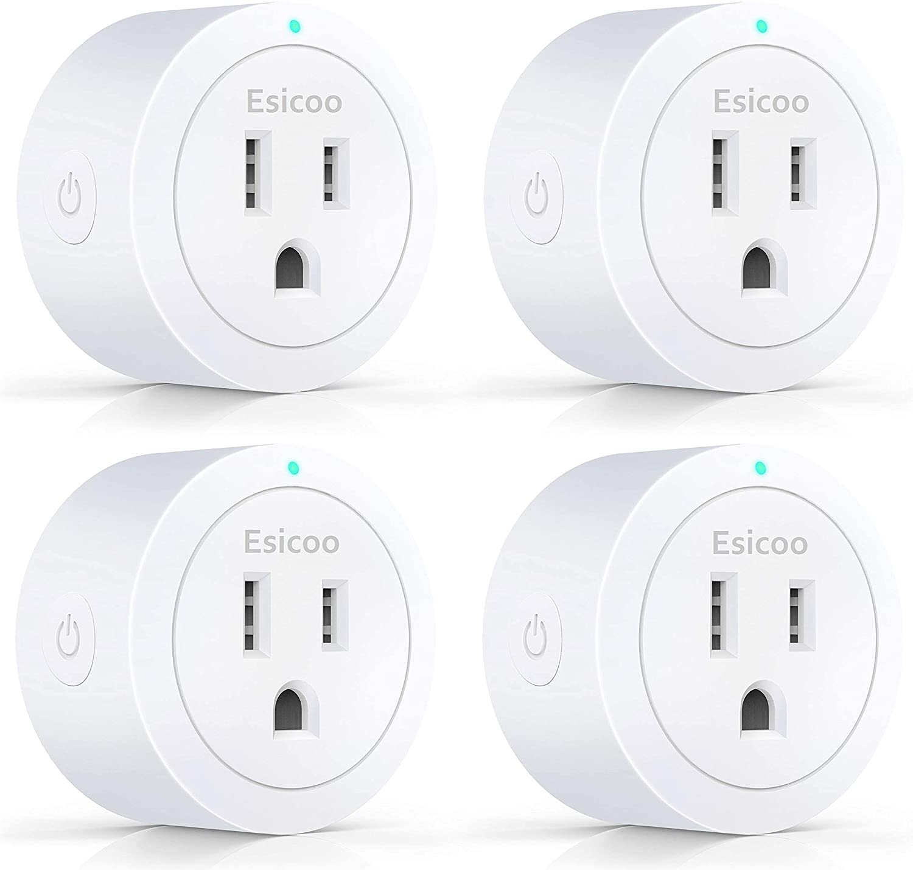

Figure 2.2.1: Esicoo Smart Plug

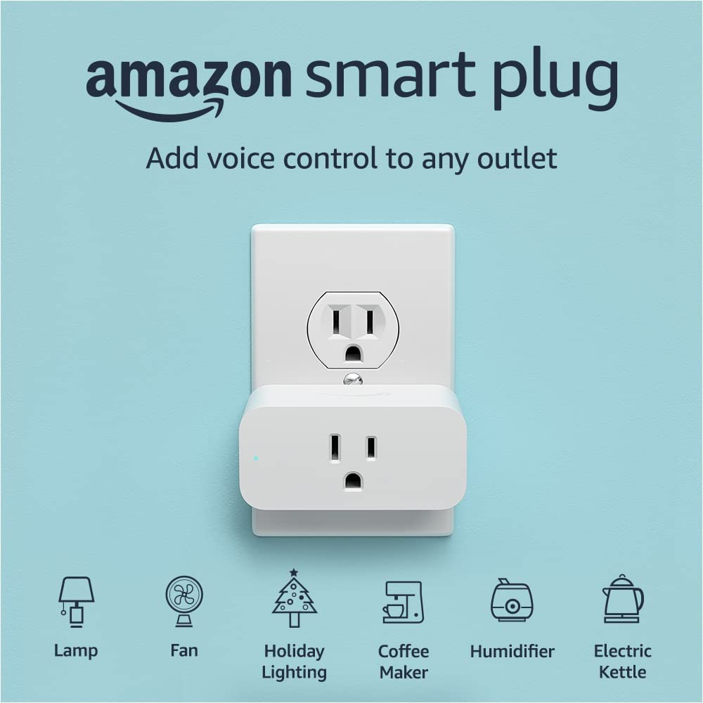

Figure 2.2.2: Amazon Smart Plug

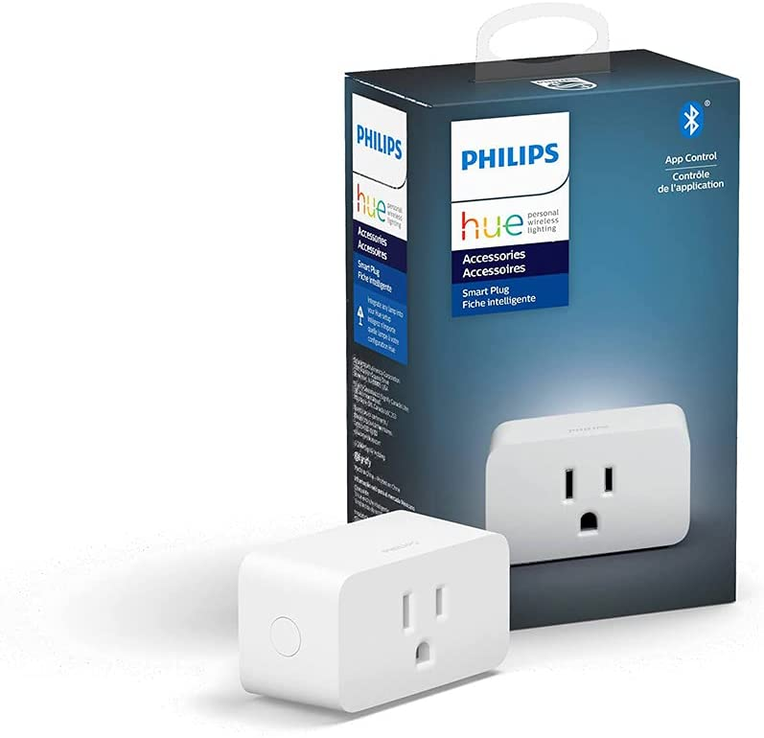

Figure 2.2.2: Philips Hue Smart Plug

The Esicoo Smart Plug is an entry-level and budget-friendly product. The cost is $19.97 for 4 packs (around $5 each). It only has a 2.4 GHz Wi-Fi connection and can only be controlled through the app.

The Amazon Smart Plug (Figure 2.2.1) and Philips Hue Smart Plug (Figure 2.2.2) are two popular two high-end smart plug products. They cost $24.99 and $29.99 each. They both feature voice AI control and app automation.

Advantages and shortcomings are obvious when comparing our project to the existing products. Our system takes advantage of the low costs and the ability to operate in long-range without Internet connections. However, our system lacks extra features in the high-end products, such as voice AI control and automation.

## Development Environment and Tools

**Hardware tools**

**Soldering station** - The multipurpose power soldering device to solder electronic components onto the printed PCBs

**Multimeter** - The tool to test voltage, current, and resistance of different nodes on the PCBs to ensure the correct operation of electronic components

**PCB fabrication company** - The place to manufacture the PCBs designed by us

**Software tools**

**Altium Designer System Engineering (SE)** - The fully-featured editor for schematics that includes powerful collaboration capabilities and a rich set of schematic capture tools to quickly create, edit, simulate, and document schematics

**Keil Microcontroller Development Kit (MDK) for ARM** - The software development solution to create, build, and debug embedded applications for Arm-based microcontrollers

**Eclipse IDE for Java EE Developers** - The tool to develop the Android app based on Java

## Related Documents and Supporting Materials

**Industrial standards**

*IEEE Standards Association. IEEE 802.11ah-2017: IEEE standard for 900 MHz license-exempt bands to provide extended-range Wi-Fi networks.*

*IEEE Standards Association. IEEE 802.11n-2009: IEEE standard for wireless networking that uses multiple antennas to increase data rates.*

## Definitions and Acronyms

AC - Alternating current

Altium - Altium Designer System Engineering (SE)

app - Application

Eclipse - Eclipse IDE for Java EE Developers

GPIO - General Purpose Input/Output

GUI - Graphical User Interface

IEEE – Institute of Electrical and Electronics Engineers

Keil - Keil Microcontroller Development Kit (MDK) for ARM

LoRa - a proprietary low-power wide-area network modulation technique based on spread-spectrum modulation techniques derived from chirp spread spectrum (CSS) technology

MCU - Microcontroller Unit

PCB - Printed Circuit Board

SNR - Signal-to-Noise Ratio

Socket - Electric socket with input and output

SPI - Serial Peripheral Interface

STM32 - STM32F103C8T6 Minimum System Development Board Module

UART - Universal Asynchronous Receiver/Transmitter

USB - Universal Serial Bus

# Design Considerations

## Realistic Constraints

Several constraints have a significant impact on the design of the system.

**Power consumption**

The power consumption of the internal system is important because the system is designed to work continuously. Excessive power consumption of the system may let the shortcomings override the advantages and make the system less meaningful. As a result, it is important to use low-power and efficient electronic components in our system.

**Voltage/current supply**

The input of the sockets must comply with the US standard of 120 V 60 Hz AC power supply. The input of the remote controller must comply with the standard of 3V or 5V DC power supply.

**Processor speed/memory size constraints**

The MCUs’ speed and memory size must be sufficient to ensure desired performance mentioned in section 2.1.

**Project time and budget**

The development of the system should be under 18 weeks. The cost of the end product should be under $100.

**Safety**

The system involves AC power. Isolation and insulation of wires are important in the system.

**Wireless transmission**

The frequency range designated to LoRa Technology in the United States is 902 to 928 MHz. The system should follow the standard. The Wi-Fi transmission should follow the IEEE standard of 802.11n. Proper wireless modules should be chosen to meet the wireless performance mentioned in section 2.1.

## System Environment and External Interfaces

**Hardware requirement**

The sockets should be powered by US standard wall sockets which are 120 V 60 Hz. The remote controller should be powered by a 5V USB-A port.

**Software requirement**

In order to use the app control, the users must have a mobile device with the software version of Android 4.4 or higher.

## Industry Standards

*IEEE Standards Association. IEEE 802.11ah-2017: IEEE standard for 900 MHz license-exempt bands to provide extended-range Wi-Fi networks.*

*IEEE Standards Association. IEEE 802.11n-2009: IEEE standard for wireless networking that uses multiple antennas to increase data rates.*

## Knowledge and Skills

**Zhuocheng Hu**

Previous knowledge and skills:

EE100 A/B - Electronic circuits

EE 120A - Logic design

EE 120B - Introduction to embedded systems

Welding

Basic skill of Altium

New knowledge and skills:  
 STM32 develop experience

ESP8266 develop experience

Altium and Keil experience

**Yaoteng Tan**

Previous knowledge and skills:

Basic knowledge of Electronic Circuits, Microcomputer Architecture, Computer Network

Basic Web development using Java SE

New knowledge and skills:

Basic knowledge of STM32 microcontroller and LoRa communication

Android Application development

**Zhengxuan Wen**

Previous knowledge and skills:

EE100 A/B - Electronic circuits

CS/EE 120A - Logic design

CS/EE 120B - Introduction to embedded systems

New knowledge and skills:

Software development experience: Keil, Eclipse, Altium

Hardware development experience: STM32, ESP8266, LoRa

## Budget and Cost Analysis

Cost for single end system:

| Quality | Item | Cost in USD |
| --- | --- | --- |
| 3 | STM32F103C8T6 | 6.48 |
| 3 | E32-900T20D LoRa SX1276 | 21.45 |
| 2 | ESP8266 Wi-Fi Module | 13.9 |
| 3 | PCB | 21.6 |
| 4 | LED | 1.48 |
| 2 | On/off switch | 1.08 |
| 3 | Button switch | 1.35 |
| 2 | SRD-05VDC-SL-C Power Relay | 0.32 |
| 2 | AC to DC converter | 4.74 |
| 2 | AMS1117 linear regulator | 1.06 |
| 2 | Bipolar (BJT) transistor PNP | 0.84 |
| 4 | 220Ω resistor | 2.56 |
| 2 | 10kΩ resistor | 0.2 |
| 1 | 0.1 µF capacitor | 0.48 |
| 1 | 220 µF capacitor | 0.44 |
| 2 | AC power cord | 5.96 |
| 2 | Socket with cable | 6.37 |
| Total | | 90.31 |

## Safety

Safety is taken into great consideration when designing the system because our system involves AC power sources which may cause safety risks if the system has design flaws. Electrician gloves and surge protectors are used whenever the tests are related to AC voltage. For better electricity isolation and insulation, the system uses printed PCBs instead of traditional wires. Minimum electricity conductive parts are exposed on the surface of the final system. To ensure extra safety, a thick layer of acrylic conformal coating covers the surface of the entire PCBs and electronic components. Electrician gloves and surge protectors will be continually used in the future when using the system.

## Performance, Security, Quality, Reliability, Aesthetics, etc.

**Performance**

The performance of the system should be promising. To achieve this goal, quality control plays an important role through development.

**Security**

The system is designed as non-serviceable and non-modifiable to minimize the danger under non-authorized repairs and modifications.

**Quality and reliability**

To ensure that the quality and reliability of the system is exceptional, extensive tests have been carried on to determine if the system works under expectation. Each hardware part has been inspected visually and tested using a multimeter to ensure proper fabrication.

**Aesthetics**

The system employs a minimalist design. The hardware parts look concise and neat. The Android app has a simple GUI. Combining the hardware and the software, the system is user-friendly.

## Documentation

The development process has been properly documented throughout the project. Each team member has a project folder including multiple sub-folders to store the documents. The documents may include design notes, engineering change notices, version updates, version control procedures, etc. All of the folders have been uploaded to Google Drive periodically to ensure the safety of the data. Team members also write reports weekly to record the progress of the project. By proper documentation, each team member can easily carry out updates on the project and revert to old versions if new designs don’t work as expected.

## Risks and Volatile Areas

N/A

# Experiment Design and Feasibility Study

This section introduces the experiments designed by ourselves that help us to evaluate the feasibility of our project ideas. And it also provides readers a rough direction to implement our project. For each experiment design, we include the corresponding objectives, setup, procedure, and expected results.

## Experiment Design

This section elaborates on the experiment design of our project. To achieve our project design objectives, we design our experiments, starting from basic functions and adding complexities layer by layer that gradually enriches our system function.

### Experiment 1: Basic IO control of STM32

(Completed by Yaoetng Tan, Zhengxuan Wen)

1. Objective:

Getting familiar with STM32 basic IO. The purpose is to learn how to manipulate STM32 basic IO on doing simple tasks, as it is unfamiliar to all of the group members. The basic IO manipulation can be used for trigging the LoRa module.

1. Setup:

STM32 Dev-board: NUCLEO-L152RE *1,

LED *1,

Button *1

1. Procedure:

Starting from blink LED on STM32 dev-board, then try to blink a discrete LED electronic components by a physical connecting STM32. Eventually, adding a button, try to blink the LED using manual input taken by the button. Has basic robustness like debouncing. The main idea of this experiment is doing qualitative observation, there is no collecting data.

1. Expected results:

Be able to blink LED by pressing the button. In other words, LED is a system output response to input taken by the button connected to the STM32 microchip.

### Experiment 2: Basic communication with LoRa module

(Completed by Yaoetng Tan, Zhengxuan Wen)

1. Objective:

Getting a basic understanding of how LoRa communication functions: the way of communication was in datagram or package, working frequency, synchronizing, rough communication range.

1. Setup:

STM32 Dev-board: NUCLEO-L152RE *2,

SX1276 LoRa module (UART) *2,

Computer with serial monitor software

1. Procedure and collecting data:

Prepare two boards that assembled LoRa modules and STM32 on each, one functions as the sender, the other functions as the receiver. Using Arduino IDE program a simple “HelloWorld” that defines a counter to record pressed times and sends simple strings between two STM32 boards using LoRa. Observe the transmitted string and SNR by the serial monitor on the computer. The collectible data of this experiment is the SNR-distance, successful transmission per 10 clicks ratio.

1. Expected results:

The basic expected result is successfully printing transmitted strings like “Hello World” on the receiver side serial port monitor. Advanced expected results will be able to record the quantitative data successful transmissions.

### Experiment 3: IO control with LoRa module

(Completed by Yaoetng Tan, Zhengxuan Wen)

1. Objective:

Build a simplex LoRa transmit demo, to get a basic understanding of how LoRa communication functions: parsing LoRa package, terminal identification, working frequency, synchronizing, rough communication range.

1. Setup:

STM32 Dev-board: NUCLEO-L152RE *2,

SX1276 LoRa module (UART) *2,

LED *1,

Button *1

1. Procedure and collecting data:

Based on the system we built in experiment 1, break input and output (button and LED) into two parts on two boards driven by STM32. Try to blink the LED on one board by pressing the button on another board. In this way, we implement basic LoRa communication, being able to send basic control command: on/off between two physically separate boards.

1. Expected results:

You should be able to blink LED on one board by pressing the button on another board remotely as a trigger sending “on” message through the LoRa module. And the system should have a basic button debouncing robustness.

## Experiment Results, Data Analysis and Feasibility

This section include the carrying out of the experiments designed above and presents experimental results. Most of the results will be qualitative analysis since most of our designed experiments are verification of feasibility.

### Experiment 1: Basic IO control of STM32

(Completed by Yaoetng Tan, Zhengxuan Wen)

This experiment is a basic simple IO function verification of your STM32 dev-board. The qualitative result is shown in the image below. The red circled LED is alternating light and dark 0.5 seconds within each second.

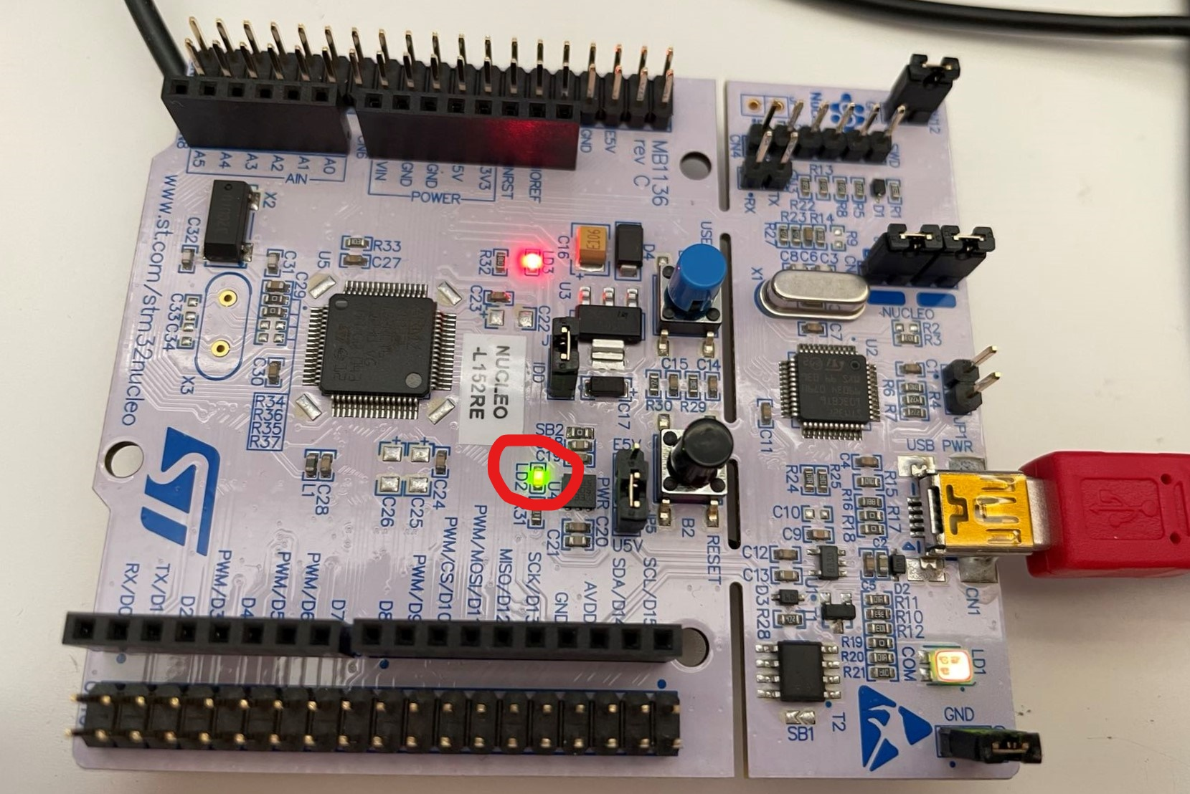

### Experiment 2: Basic communication with LoRa module

(Completed by Yaoetng Tan, Zhengxuan Wen)

In this experiment, we sent the string: “hello” with package sequence number using LoRa module, every 1 second. The following images are the wiring diagram and the physical wired.

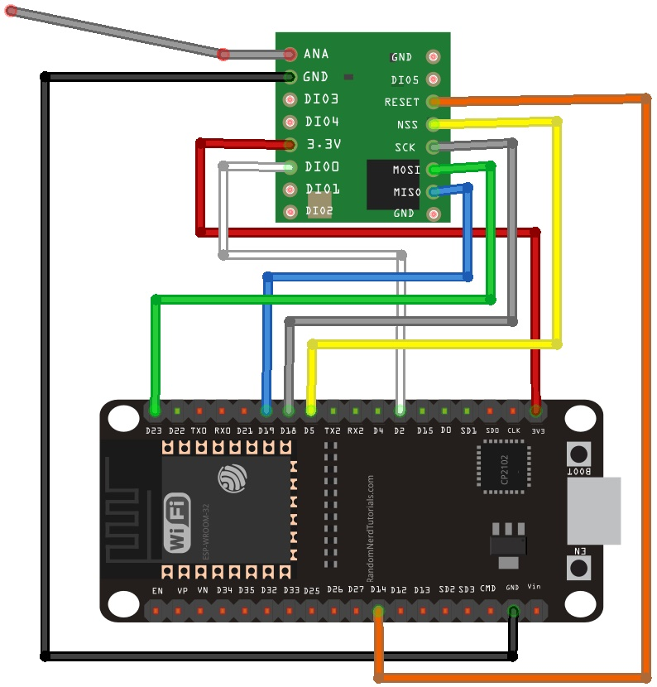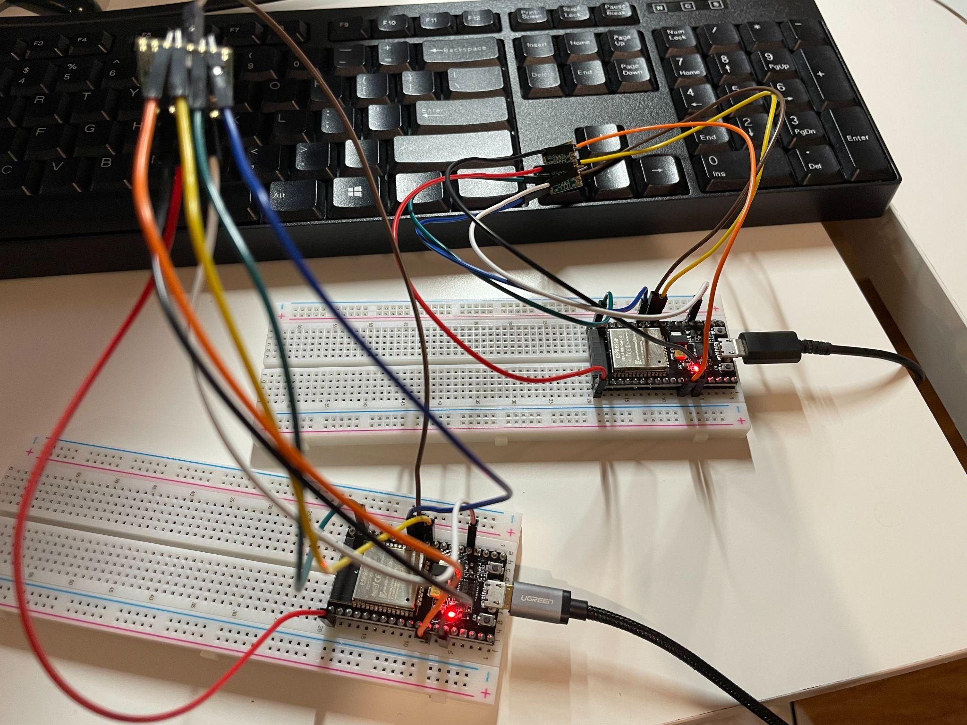

Checking the packages send between two LoRa modules by forwarding the serial port datas on to therminal using a serial port monitor software. If you want some quantitative results you can print the package SNR by calling the library function.

### 

### Experiment 3: IO control with LoRa module

(Completed by Yaoetng Tan, Zhengxuan Wen)

Below is the qualitative result of our experiment 2. In this experiment, we can blink the LED on other boards by pressing the button on a physically separated board and the control message is sent by the LoRa module.

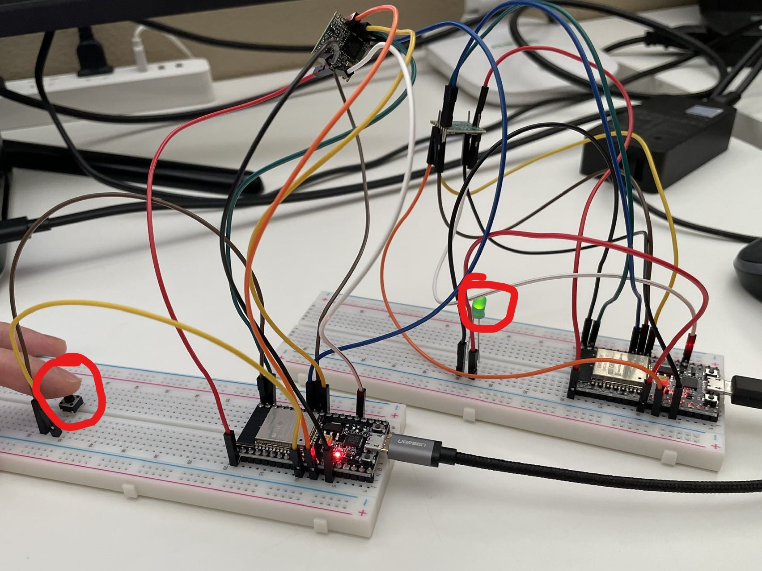

# Architecture and High Level Design

## System Architecture and Design

(Completed by Yaoetng Tan, Zhengxuan Wen, Zhuocheng Hu)

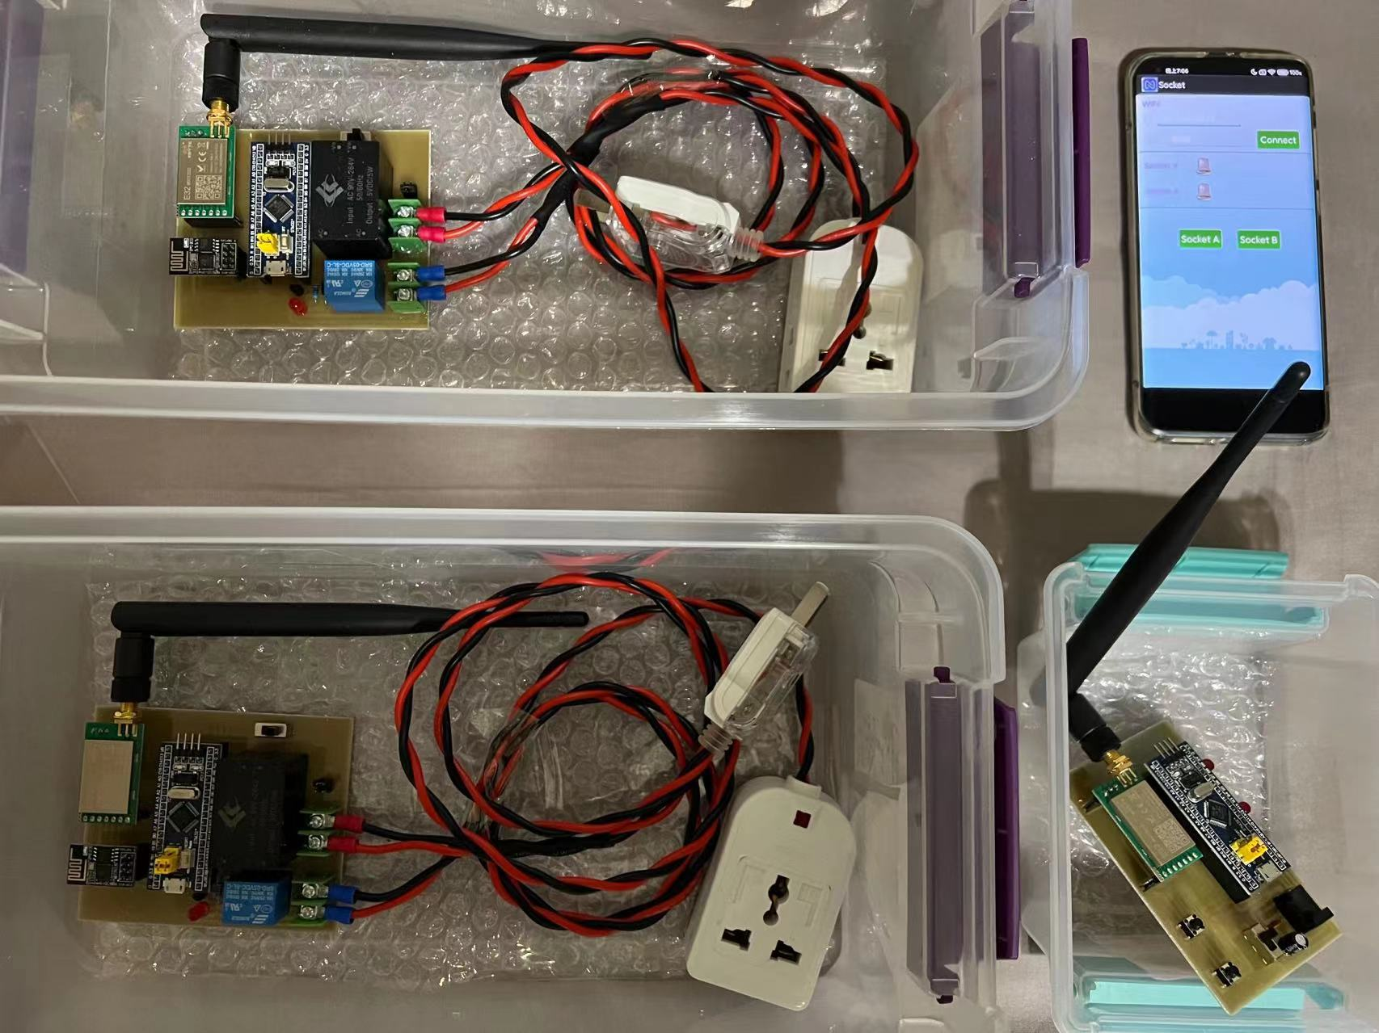

Figure 5.1.1: System overview

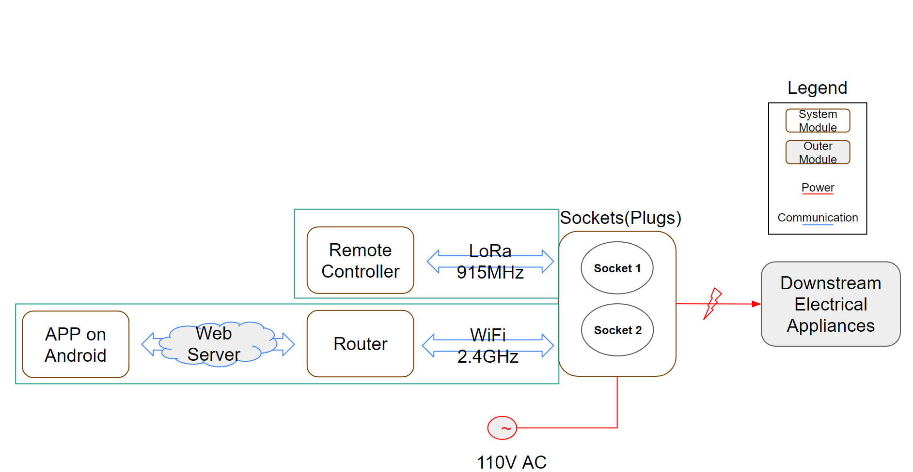

Figure 5.1.2: High-level system architecture and design

On the high level, the system includes 3 major parts, which are the sockets, the remote controller, and the app/server.

The sockets serve the main function of the system to turn on or off downstream electrical appliances when necessary. It can be connected to existing wall outlets and it has its own outlet for the other electrical appliances to connect to. They receive commands from the remote controller and the app. They also report their status back to the remote controller and the app.

The remote controller serves the function of sending commands to and controlling the sockets within a specific range. It also receives the status reported from the sockets. The communication is done based on a spread-spectrum modulation technique derived from chirp spread spectrum technology, which is called LoRa.

The app/server serves the function of sending commands to and controlling the sockets within an unlimited range, as long as both the app and the sockets have an Internet connection. It also receives the status reported from the sockets. The communication is done based on the 2.4 GHz Wi-Fi connection and the Internet.

Combining all the 3 major components, the users are able to control the sockets and check their status both in short-range and long-range.

## Hardware Architecture

(Completed by Zhuocheng Hu)

**Sockets**

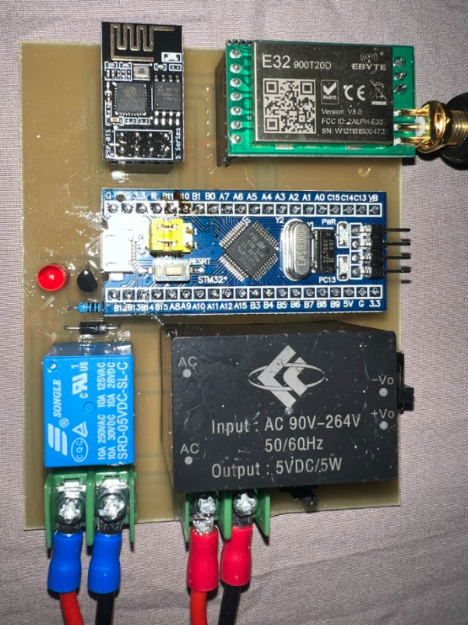

Figure 5.2.1: Socket

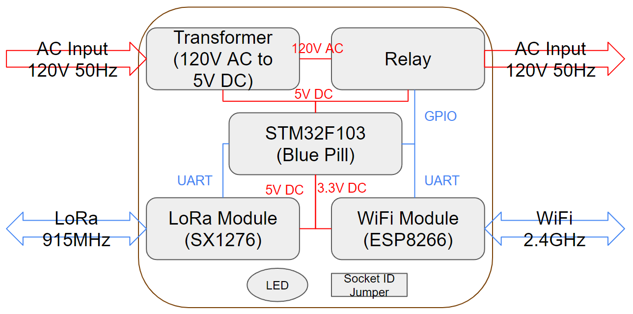

Figure 5.2.2: Diagram of sockets design

The major components of the socket hardware architecture are the transformer, the relay, the STM32, the LoRa Module, the Wi-Fi Module, the LED, and the socket ID Jumper.

The transformer is used to transfer the AC source to the DC source to correctly power the STM32, the LoRa module, and the Wi-Fi module.

The relay is directly connected to the AC power source controls the socket’s ON/OFF states based on the commands of the STM32.

The STM32 is the processing core of the socket. It receives data from and sends data to the peripheral components, including the relay, the LoRa module, and the Wi-Fi Module. It also stores the embedded programs and does all of the calculations.

The LoRa module is used for communication with the remote controller. It sends and receives commands.

The Wi-Fi module is used for communication with the app.

The LED indicates the status of the socket, either ON or OFF.

The socket ID jumper is used to identify different sockets for the remote controller and the app.

**Remote controller**

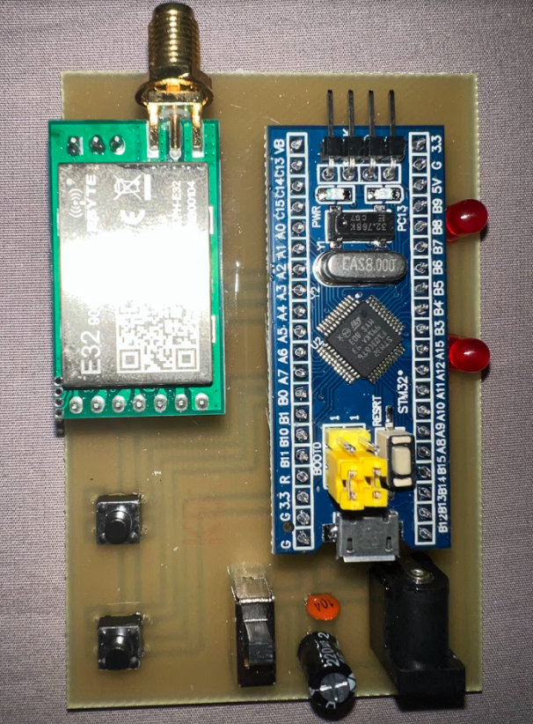

Figure 5.2.3: Remote controller

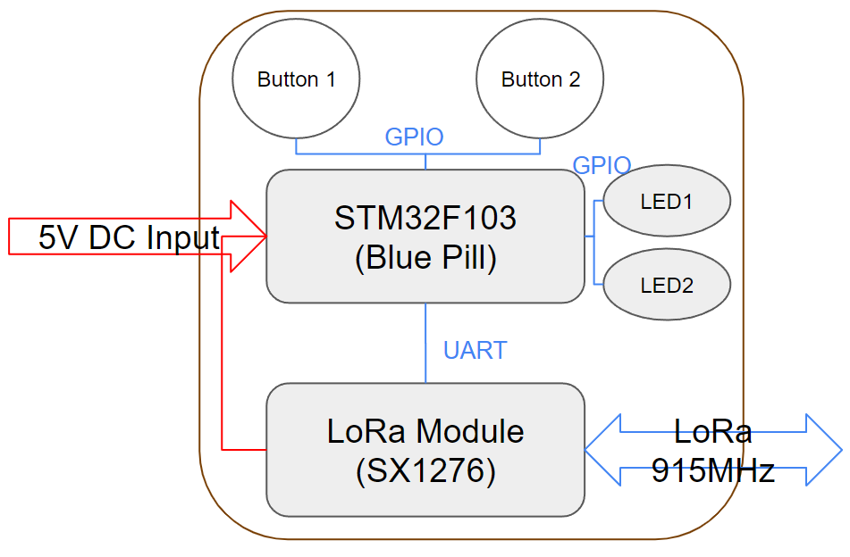

Figure 5.2.4: Diagram of remote controller design

The major components of the remote controller are the 2 buttons, the STM32, the 2 LEDs, and the LoRa module.

Pressing the 2 buttons sends switching states commands to the socket, through the STM32 and LoRa module.

The STM32 is the processing core of the socket. It receives data from and sends data to the peripheral components, including the LEDs and LoRa module. It also stores the embedded programs and does all of the calculations.

The 2 LEDs indicate the status of the sockets, either ON or OFF, correspondingly.

The LoRa module is used for communication with the sockets. It sends and receives commands.

## Software Architecture

(Completed by Yaoetng Tan, Zhengxuan Wen)

This Subsection introduces the software parts of our system, including basic flow charts and modules of each software. Our system consists of three sets of software in total: Remote Controller, Socket, Android app.

1. Remote Controller:
   1. Flow charts

The chart demonstrates our Remote Controller workflow: initializing system clock, interrupt control, and all the necessary port resources at the beginning of the main function. Since we have all the inputs source from two buttons and a LoRa module that is manipulated by the UART port, in the main loop, basically the program checks the update within each loop and calls corresponding event handlers if the condition is triggered.



* 1. Modules

The major modules of Remote Controller software include two Key_Pin variables as an abstraction for two physical buttons. Similarly, two LED_Pin variables for two LEDs and two UART state variables indicate the state changes of the UART port.



* 1. File Structure

The whole directory of Remote Controller software is shown as follows. Our software logic is in main.c under USER and UART.c/.h under SRC. The rests are necessary libraries and dependencies for our project from hardware manufacturers.



1. Socket:
   1. Flow charts

Our Socket board workflow is shown below. Similar to the Remote Controller, initializing system clock, interrupt control, and all the necessary port resources at the beginning. And the read the Socket ID pin as the identification of Socket, which maps to the jumper state on the physical board. In the main loop, we maintain a timer that is used for iterating millisecond counter variables. The counter variables are used for counting WiFi connection timeout.



* 1. Modules

The major modules of Remote Controller software are Relay_Pin, LED_Pin, Adress_Pin variables corresponding to relay, LED, address pin on physical board. And four logic counters variables. Self-defined functions: User_GPIO_Init() is for GPIO initialization, and TIM2_IRQHandler() iterates counter variables triggered by system clock.



* 1. File Structure

Our implementation of software logic is in main.c under USER and .c/.h files under SRC. The rest of the files under directories are necessary libraries and dependencies for our project from hardware manufacturers.



1. Android app:
   1. Flow charts

We implement the app on the Android platform based on Java programming language and Android SDK.

An Android project using MainActivity class for program entrance. The onCreate(), onDestroy() methods are necessary for each activity class and will be called at the beginning/end of the activity life cycle. Basically you can take the onCreate() as initialization, where it creates the app interface, necessary objects, and initializes variables.



* 1. Modules

The main modules of the app can be described as follows. Button click listener specifically listening to the user click and trigger the corresponding click event. And a message handler is used for dealing with connection states messages and pop up corresponding toasts to inform connection states.



* 1. File Structure

All the designed logic code files are under the src directory.



## Rationale and Alternatives

The system's design is done through multiple industry-standard development tools, including the Altium and the Keil. Their templates of hardware and software guide us to design our system professionally. The system architecture above is chosen to best fit our design objectives based on realistic constraints.

During the development of the system, we have experimented with different alternatives which didn’t meet our design objectives.

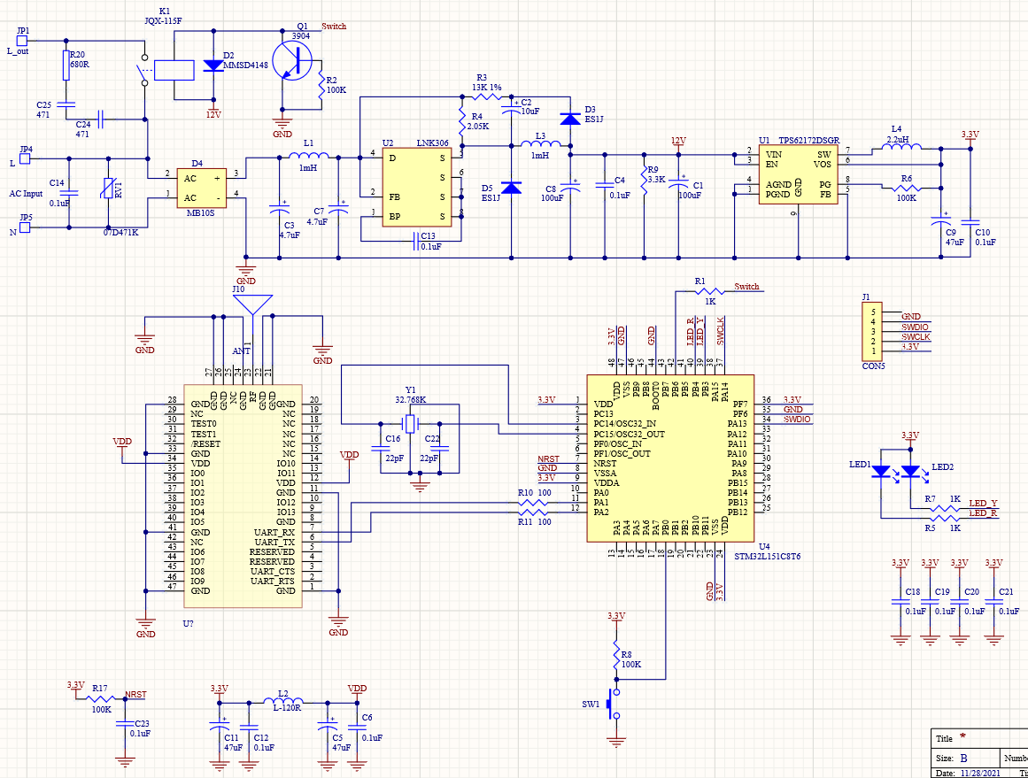

Figure 5.4.1: Initial hardware design

The Initial hardware design (Figure 5.4.1) didn’t offer connectivity to the Internet. It had much more components compared to the final design, and many of them were either difficult to purchase or extremely hard for us to solder manually. Moreover, the design significantly increases the cost of our system. Therefore, we simplified the hardware design with soldering-friendly components and added Internet connectivity. Eventually, the final design is successful in functioning properly.

# Data Structures

## Internal software data structure

N/A

## Global data structure

N/A

## Temporary data structure

N/A

## Database descriptions

N/A

# Low Level Design

## *Socket - Hardware*

(Completed by Zhuocheng Hu)

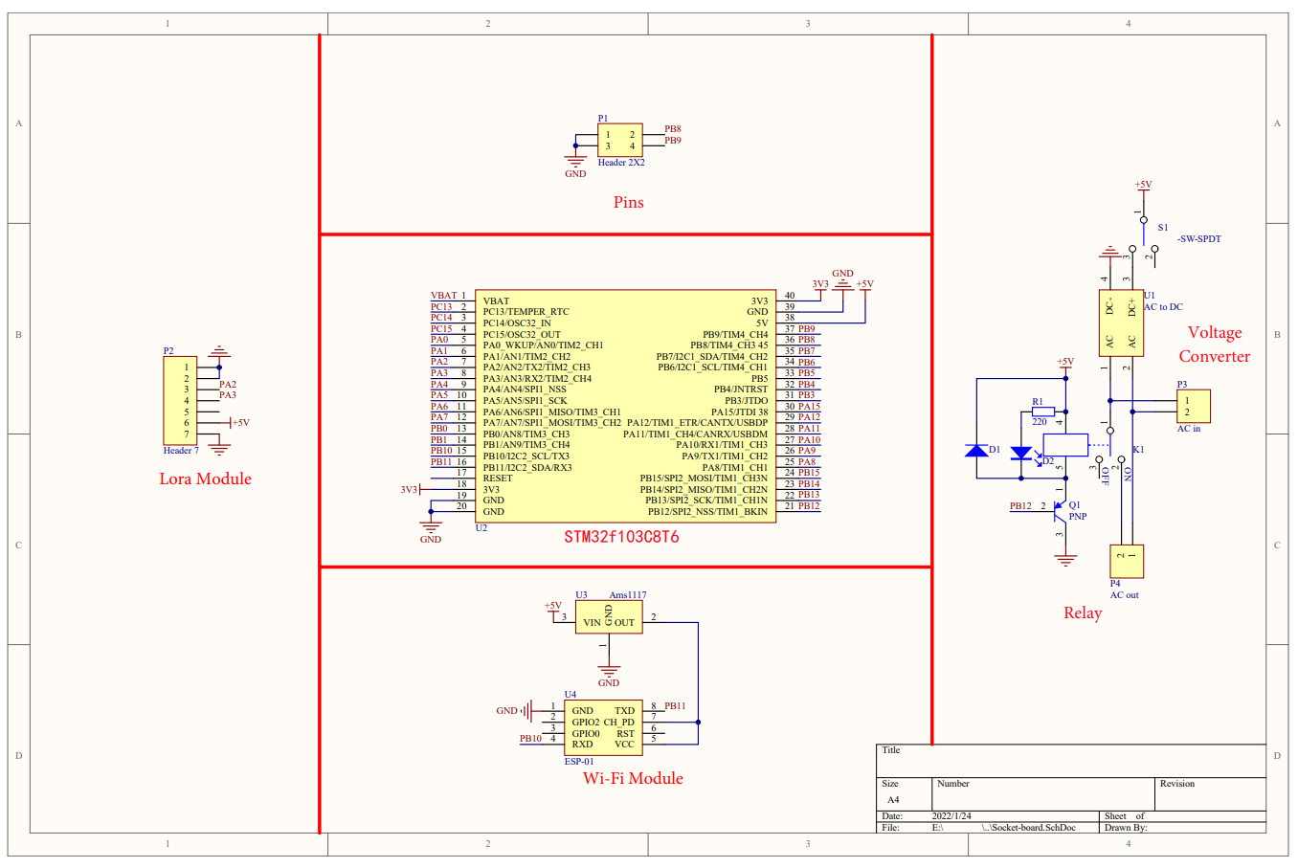

Figure 7.1.1: Socket hardware design

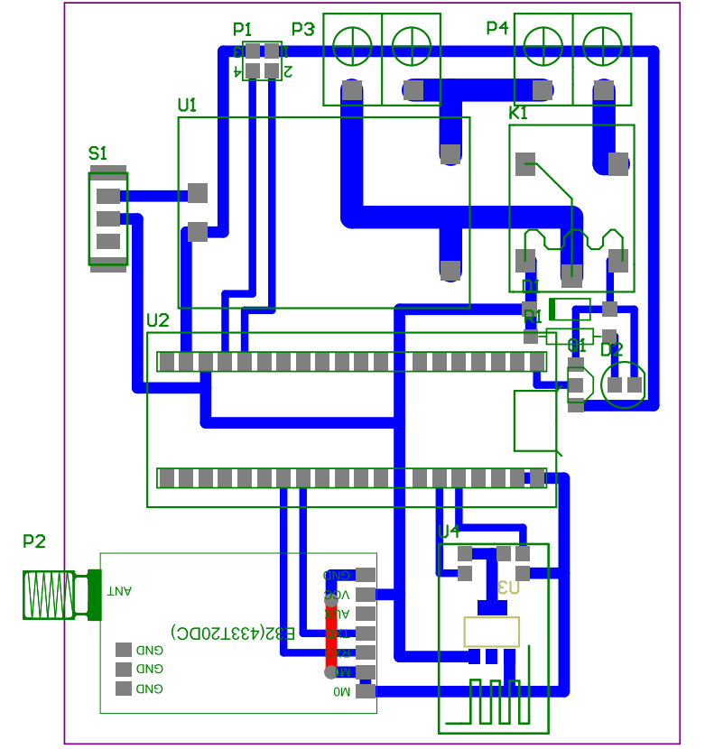

Figure 7.1.2: Socket PCB layout

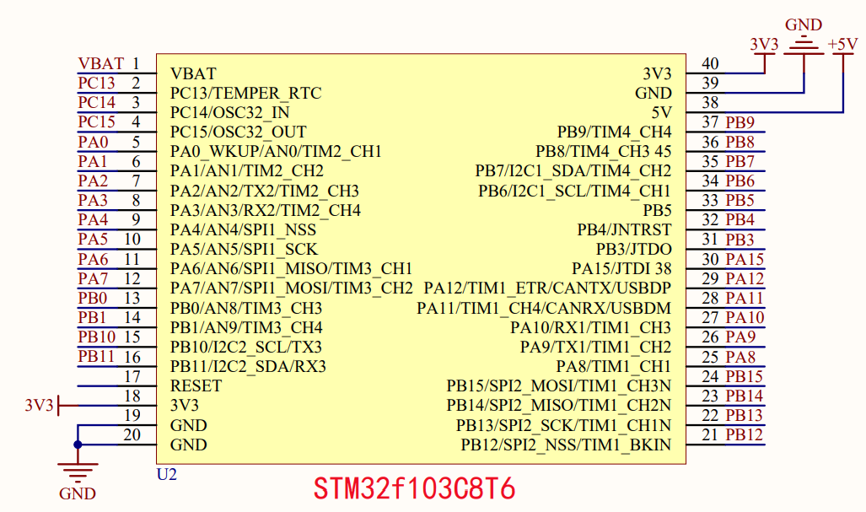

Figure 7.1.3: STM32f103C8T6

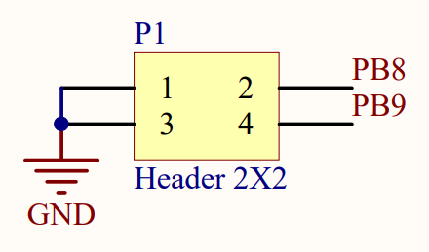

Figure 7.1.4: Pin jumper

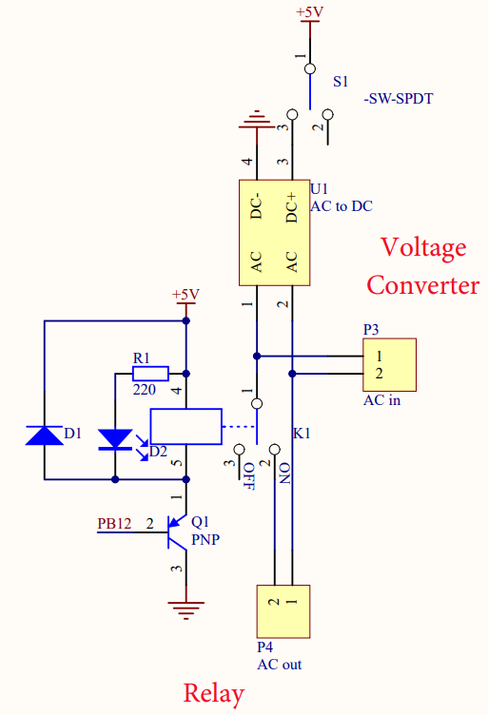

Figure 7.1.5: Relay and voltage converter

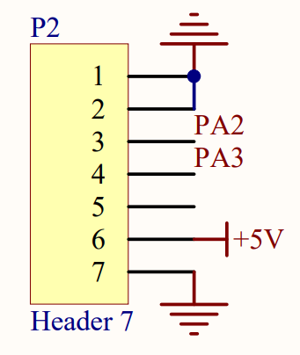

Figure 7.1.6: LoRa module

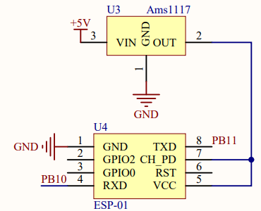

Figure 7.1.7: Wi-Fi module

### Processing narrative for *Socket - Hardware*

This module represents the low-level hardware design of the socket. The details of different components will be discussed in detail. This module serves the function of the socket at the hardware level.

### *Socket - Hardware* interface description

This module accepts input as commands from the remote controller through the LoRa chip and from the app through the Wi-Fi chip.

It output commands to the relay to control the states of the outlet.

### *Socket - Hardware* processing details

**PCB (Figure 7.1.2)**

The PCB integrates all components in the module. It mechanically supports and electrically connects electronic components using conductive pathways.

**STM32f103C8T6 (Figure 7.1.3)**

Detailed description - ARM® Cortex®-M3 series Microcontroller IC 32-Bit 72MHz 64KB (64K x 8) FLASH

Pin connection - The STM32 is powered by the voltage transformer through its 5 V DC pin. The GND pins are grounded. The PB8 and PB9 GPIO pins are connected to the pin jumper, which will identify the socket to be A or B accordingly. The UART2 serial communication port of the STM32, which includes PA2 and PA3, connects to the LoRa chip to realize communication with the LoRa module. This UART communication protocol uses asynchronous serial communication with configurable speed. The other UART port, UART3, which includes PB10 and PB11, connects to the Wi-Fi chip to realize asynchronous serial communication. PB12 connects to a PNP transistor to indirectly control the relay.

**Pin jumper (Figure 7.1.4)**

The pin jumper includes PB8, PB9, and the ground. If PB8 is connected to the ground, the socket is identified as socket A. If PB9 is connected to the ground, the socket is identified as socket B.

**Relay and voltage converter (Figure 7.1.5)**

Detailed description - Relay - Rated load: 10A 250VAC/28VD; Voltage transformer - Input: AC 90 V - 264 V 50-60 Hz Output: 5 V DC/5 W

Connection - Relay - The relay is placed on the cold side of the socket AC outlet. The switch pin is connected to the P conjunction of the PNP transistor. When PB12 = 0, the current will pass through the PNP transistor and the relay, which turns the sockets on, vice versa. It also has an LED in parallel connection with it to indicate the status and an IN4007 diode to stabilize the current when the relay is switching states; voltage transformer - The input of the voltage transformer connects to the 120 V 60 Hz AC wall outlet, the output is connected to the STM32 and Lora chip.

**LoRa chip (Figure 7.1.6)**

Detailed description - E32-900T20D: A wireless UART module based on SETECH’s sx1276 RF chip. Works in 862 MHz ~ 931 MHz. Includes LoRa spread spectrum technology, TLL output.

Connection - The PWR pin connects to the voltage transformer to gain a 5 V DC input. The TXD pin is connected to PA3, and the RXD pin is connected to PA2 for the serial communication with STM32. The GND pin is properly grounded. The antenna has been connected to increase signal strength.

**Wi-Fi chip (Figure 7.1.7)**

Detailed description - ESP-01: A wireless module based on core processer ESP8266. Ultra-low-power 32-bit MCU, with the 16-bit short mode, clock speed 80 Mhz or 160 Mhz. Supports the RTOS, integrated Wi-Fi MAC/BB/RF/PA/LNA, on-board antenna.

Connection - The VCC pin connects to the Ams1117 voltage regulator to achieve a 3.3 V DC power input. The TXD pin is connected to PA11, and the RXD pin is connected to PA10 for the serial communication with the STM32. The GND pin is properly grounded. The antenna has been connected to increase signal strength.

## *Remote controller - Hardware*

(Completed by Zhuocheng Hu)

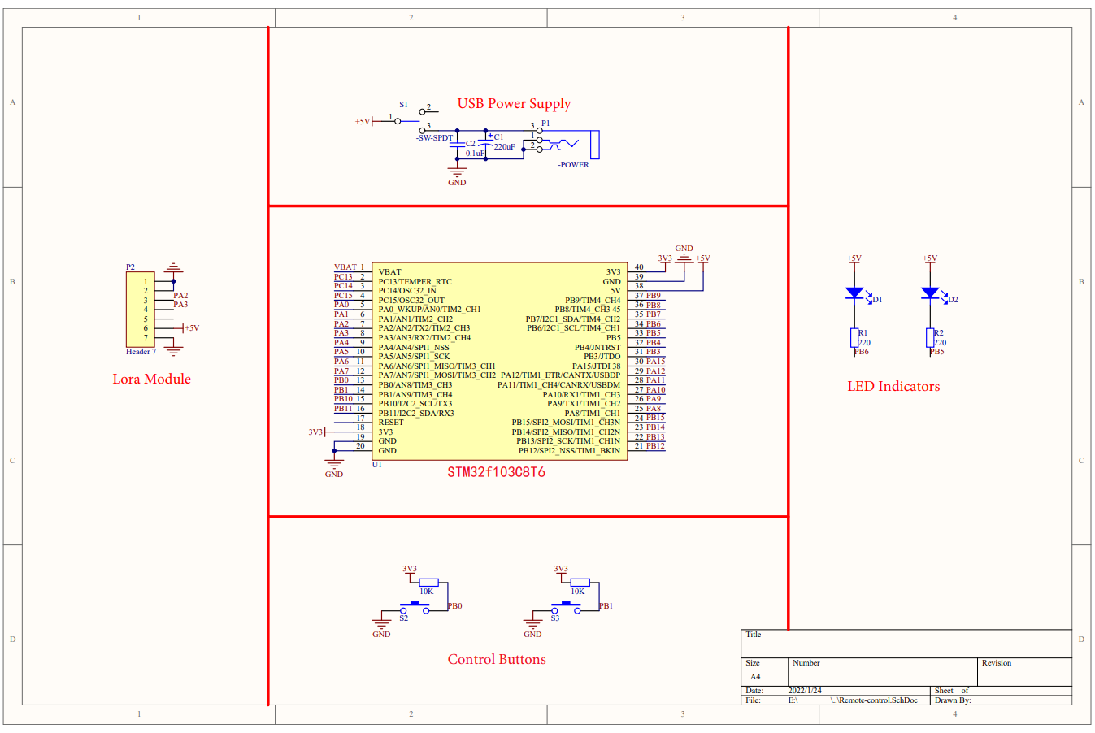

Figure 7.2.1: Remote controller hardware design

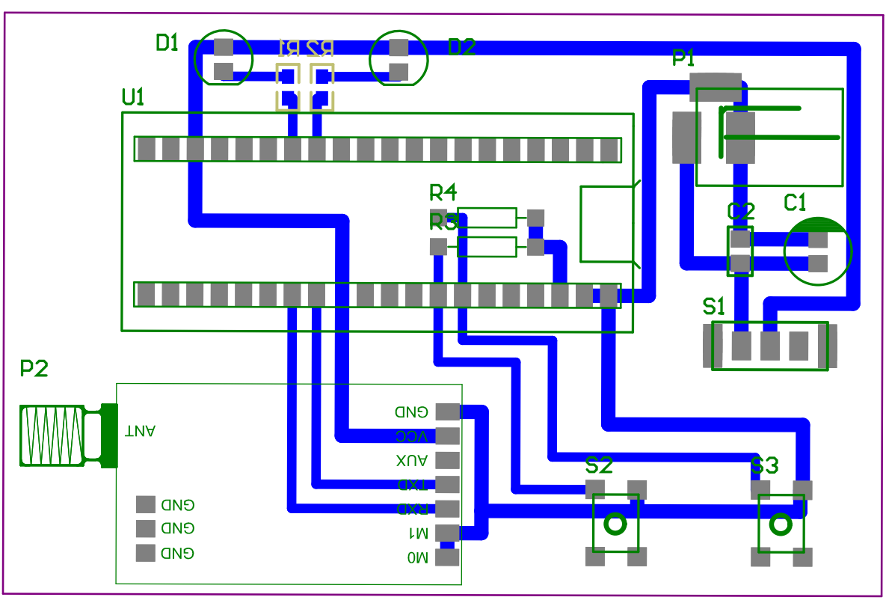

Figure 7.2.2: Remote controller PCB layout

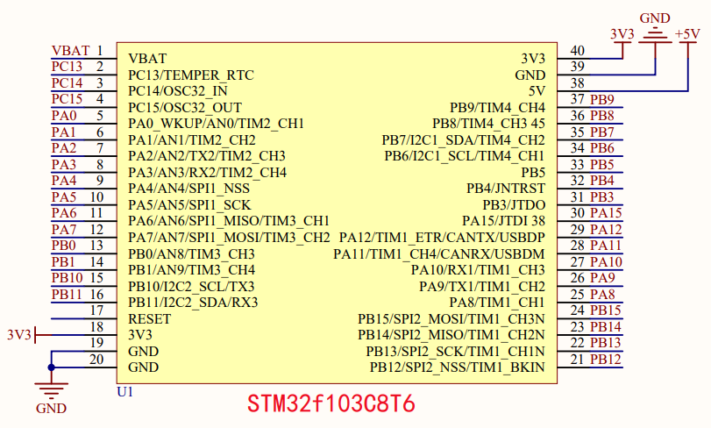

Figure 7.2.3: STM32f103C8T6

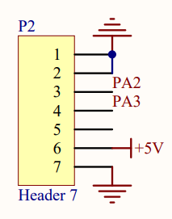

Figure 7.2.4: LoRa Module

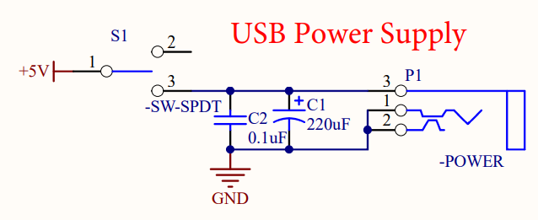

Figure 7.2.5: Remote controller power supply

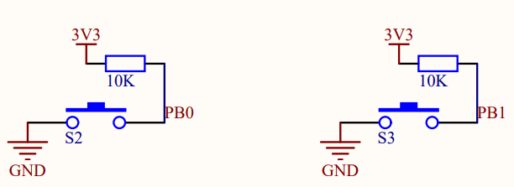

Figure 7.2.6: Remote controller buttons

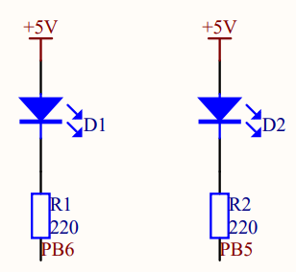

Figure 7.2.7: Remote controller LEDs

### Processing narrative for *Remote controller - Hardware*

This module represents the low-level hardware design of the remote controller. The details of different components will be discussed in detail. This module serves the function of the remote controller at the hardware level.

### *Remote controller - Hardware* interface description

This module accepts input as commands from the sockets through the LoRa chip.

It outputs commands to the sockets through the LoRa chip to control the states of the sockets.

### *Remote controller - Hardware* processing details

**PCB (Figure 7.2.2)**

The PCB integrates all components in the module. It mechanically supports and electrically connects electronic components using conductive pathways.

**STM32f103C8T6 (Figure 7.2.3)**

Detailed description - ARM® Cortex®-M3 series Microcontroller IC 32-Bit 72MHz 64KB (64K x 8) FLASH

Pin connection - The STM32 is powered by the voltage transformer through its 5 V DC pin. The GND pins are grounded. The UART2 serial communication port of the STM32, which includes PA2 and PA3, connects to the LoRa chip to realize communication with the LoRa module. This UART communication protocol uses asynchronous serial communication with configurable speed. PB0 and PB1 connect to 2 control buttons, which sense user inputs. PB6 and PB7 connect to the two LEDs, which indicate the status of the sockets.

**LoRa chip (Figure 7.2.4)**

Detailed description - E32-900T20D: A wireless UART module based on SETECH’s sx1276 RF chip. Works in 862 MHz ~ 931 MHz. Includes LoRa spread spectrum technology, TLL output.

Connection - The PWR pin connects to the voltage transformer to gain a 5 V DC input. The TXD pin is connected to PA3, and the RXD pin is connected to PA2 for the serial communication with STM32. The GND pin is properly grounded. The antenna has been connected to increase signal strength.

**Power supply (Figure 7.2.5)**

Connection - The power supply is designed to be powered by 5 V DC, supplied by USB ports of personal computers or power banks. It includes an ON/OFF switch to open or close the whole remote controller circuit. A 0.1 uF capacitor and a 220 uF capacitor are used to stabilize the power input.

**Buttons (Figure 7.2.6)**

Connection - Each button connects to the ground, PB0/1, and a 10 kΩ resistor in series. When the buttons are pressed, PB0/1 will have an input of 0. When the button is released, PB0/1 will have an input of 1.

**LEDs (Figure 7.2.7)**

Connection - Each LED connects to the 5 V DC power supply, PB5/6, and a 220 Ω resistor in series. When PB5/6 = 0, voltage and current will exist over the LEDs, which makes the LEDs turn on.

## *Socket - Software*

(Completed by Zhengxuan Wen)

This section introduces low-level design (implementation-oriented) of the socket board software. We first present all the files that contain our main logic, then go into the technical details of each module.

Directory Structure:

./USER/main.c

./MyCode/Timer2.c

./MyCode/Timer2.h

./MyCode/UART2.c

./MyCode/UART2.h

./MyCode/UART3.c

./MyCode/UART3.h

./MyCode/ESP8266.c

./MyCode/ESP8266.h

./MyCode/AT_Command.c

./MyCode/AT_Command.h

### Processing narrative for *Socket - Software*

File main.c is the entry of whole socket program, which consists the socket program main loop. For each loop, it checks LoRa come-in package by looking up the UART states change. And dealing with LoRa packet by calling UART handler. Besides, the program maintains a clock that iterates counter variables for counting WiFi connection timeout in each loop. Except for main.c, we defined module-related functions in the corresponding module named files. Basically, they are customized initialization and handler functions in Timer and UART. And AT command parsing functions in AT_Command.

### *Socket - Software* interface description

Socket software has two UART logic interfaces in total, corresponding to the hardware interfaces the board used, that is, the UART2/3 list above. UART2 describes the interface manipulate logic of the LoRa module and UART3 describes the interface manipulate logic of the WiFi module ESP8266.

### *Socket - Software* processing details

**Timer2**

In Timer2.h, we only declare a timer initialization function TIM2_Int_Init(u16 arr,u16 psc); And the define the timer initialization function body in Timer2.c. The usage of this function is initializing a timer by given timer frequency (uint 16 type parameter arr) and prescale value for clock frequency divisor (uint 16 type parameter psc), and usually set it as 7199 when initializing a timer.

**UART2/3**

Both UART2 and UART3 files are functionally the same, we declare three functions: UART_Init(u32 bound); UART_SendByte(unsigned char byte); UART2_SendStr(unsigned char *s); And two external variables extern unsigned char Uart2_Receive_Data; extern unsigned char Uart2_Receive_Change; in UART.h files and leave their definitions in the UART.c file. Three functions are used for initialization, sending control messages described in bytes and sending control messages described in strings. Two variables are used for indicating the UART interface states: whether there are data come in or not.

**ESP8266**

Similar to UART, ESP8266 module has three functions: ESP8266_Init(), ESP8266_Read_Data(), ESP8266_Send_Data(unsigned char *Send_Data) for initialization, sending data, read received data respectively. And three variables: ESP8266_Receive_Data, ESP8266_Receive_Change, WIFI_Connect for indicating module receive states and WiFi connection state. Except for these, we pre-define a constant ESP8266_BUFFER_SIZE as 50 for program readability.

**AT_Command**

AT_Command has the most complex logic among all of the modules of the socket software, and also this is where the challenge is as a WiFi module involved for connectivity feature.

In this module, we pre-define four constants: AT_BUFFER_SIZE 256, which is 8 bits, the AT command return buffer size; AT_Command_Data_Long 250, the length of AT command in decimal; AT_Response_Data_Long 50, the length of AT command response in bytes; And AT_WiteRepeat_Data_Long 15, the writing repeat data length in 15 bytes.

Nine functions: AT_CommandSend for sending AT commands; AT_Command_Data_AddByte, for adding bytes into AT command data; AT_Uart_DataInit() for initialization of UART WiFi module; AT_Uart_Data_Receive for dealing with UART come in data; AT_SendByte and AT_SendStr for sending AT data in bytes or string type; AT_STRSTR, take in two char, a customized string matching function; AT_ReceiveData_Disable, it should be used as timed loop call, it is recommended to call once every 100ms; AT_Command_Replace to replace AT command.

## *Remote Controller - Software*

(Completed by Yaoetng Tan, Zhengxuan Wen)

This section introduces low-level design (implementation-oriented) of remote controller software.

Directory Structure:

./USER/main.c

./MyCode/Timer2.c

./MyCode/Timer2.h

./MyCode/UART2.c

./MyCode/UART2.h

### Processing narrative for *Remote Controller - Software*

Again the main.c file is the entry of the whole remote controller program, which is responsible for the organization of running the whole controller program. Similar to the socket that contains a LoRa module. For each loop, it checks LoRa come-in package by looking up the UART states change. Except for this, it also checks two buttons' states at each loop. The button on the controller is used for controlling the corresponding socket power. If one of the buttons was pressed or received the package from the LoRa module about the power states of the socket, it will run a handler to light up the corresponding LED, which indicates the power state of the socket.

### *Remote Controller - Software* interface description

Remote Controller has a LoRa uses a UART interface, so the abstraction of the interface in the software was UART and it is the only interface the software has, relatively simple compared to the socket.

### *Remote Controller - Software* processing details

**Timer2 (Similar to socket software)**

In Timer2.h, we only declare a timer initialization function TIM2_Int_Init(u16 arr,u16 psc); And the define the timer initialization function body in Timer2.c. The usage of this function is initializing a timer by given timer frequency (uint 16 type parameter arr) and prescale value for clock frequency divisor (uint 16 type parameter psc), and usually set it as 7199 when initializing a timer.

**UART2/3 (Similar to socket software)**

Both UART2 and UART3 files are functionally the same, we declare three functions: UART_Init(u32 bound); UART_SendByte(unsigned char byte); UART2_SendStr(unsigned char *s); And two external variables extern unsigned char Uart2_Receive_Data; extern unsigned char Uart2_Receive_Change; in UART.h files and leave their definitions in the UART.c file. Three functions are used for initialization, sending control messages described in bytes and sending control messages described in strings. Two variables are used for indicating the UART interface states: whether there are data come in or not.

## *Connectivity App - Software*

(Completed by Yaoetng Tan)

./src/com/wifi/activities/MainActivity.java

./src/com/wifi/activities/SplashActivity.java

./src/com/wifi/utils/IOUtil.java

./src/com/wifi/utils/ToastUtil.java

./src/com/wifi/utils/MyConstant.java

./gen/com/wifi/BuildConfig.java

./gen/com/wifi/R.java

### Processing narrative for *Connectivity App - Software*

The connectivity app was implemented as an Android application in Java programming language. Unlike previous board software and typical Java program, the entry of an Android app is the main activity class. For convenience and intuitiveness, we named the file as MainActivity that put the main activity class. The main connectivity initialize app UI and data at the beginning of the whole activity cycle. After the user type in the server IP address and port, it will try to build a TCP connection to the server, which will be used for forwarding control messages later on. After the connection is successfully set up, the socket power control message can be sent to the socket through the app.

### *Connectivity App - Software* interface description

The MainActivity.java is for holding the whole logic of the app, and SplashActivity.java is the loading activity when you open the app on the Android phone. Three utility files under the utils directory contain Java IO-related methods, Toast-related methods, and some byte constants used as agreed communication rules (or protocol in terminology). (Toast Utility is a pop-up message box in Android SDK, we used it for showing connection states in the app)

### *Connectivity App - Software* processing details

This section elaborates the implementation of the app entry MainActivity class. The class MainActivity extends the Activity class from android SDK.

**MainActivity**

The class has 15 member variables in total. Except for basic components variables like buttons, icons, and views. Typically, significant variables are String ip, int port records server address information; boolean isConnect indicates the TCP connection status; socket, reference for socket object used for building TCP connection between app and server; Thread socketThread, reference for socket child thread, with this thread we implemented to check and update socket status on controller LEDs while maintaining the TCP connection simultaneously.

The class has one subclass. The socket thread is implemented as a subclass in the MainActivity class instead of an independent class, the advantage of using a subclass is to manipulate the parent class private attributes easily and keep the program architecture simple.

The class has two objects. During the main activity of the app, the program listens to button click events by a Button.OnClickListener object in the MainActivity class. The Button.OnClickListener class is from the Android SDK, we only override the onClick() method to update sockets’ power status icons when the app has received socket status update from the server. The other object is a customized message handler used Handler class from the Android SDK. This object is responsibles for server connection status messages updating.

The class has 10 functions. Method onCreate() calls methods: initEvent(), initData(), initView() and startAlarm() at the beginning of the main activity life cycle to initialize the necessary components of UI and necessary variables, objects to run the program. The method initEvent() mainly try to build a TCP connection to a given address server, by calling TcpServerConnecting(). When user quit the app on the Android terminal, the method onDestroy() will be called by the Android app framework, and kill all the threads and close system resources like TCP connection in our app.

# Technical Problem Solving

## The PCB Design Problem

(Completed by Zhuocheng Hu)

PCB boards provided by UCR did not meet our needs because the programming and solder pins are too small and dense, which made it extremely hard to solder the components manually.

## Solving the PCB Design Problem

(Completed by Zhuocheng Hu)

We simplified the hardware design with soldering-friendly components and added components for Internet connectivity. We sent out the new design for an outer company to complete the PCB fabrication process. The outcome was satisfying. By solving the problem, we realized the importance of realistic constraints. Even if the design may work well theoretically, there is much more to consider in real-world situations.

## The Keil Compiling Problem

(Completed by Yaoetng Tan, Zhengxuan Wen)

During the early stage of the development, we encountered difficulty compiling an elementary practice program in Keil. Keil showed numerous errors even if we verified the correctness of the codes multiple times.

## Solving the Keil Compiling Problem

(Completed by Yaoetng Tan, Zhengxuan Wen)

We researched Internet resources for help. After a long time later, we found the cause to be the missing startup file of the STM32. After we added the correct startup file, we successfully solved the problem. We learned the importance of paying attention to details by solving this problem. Besides major components, minor issues can also lead to a complete failure of the system. It made us pay more attention to details in future development.

# User Interface Design

We provide the user an Android app to enable remote mobile control through the Internet. The user interface of our project consists of only one major activity page.

## Application Control

The mobile control sends commands to the sockets(plugs) via the Internet. Specifically, a web server that has a public IP set between the app and end system receives the request from the app and forwards corresponding control messages to the socket boards to achieve control of the sockets.

## User Interface Screens

Major user interface screens:

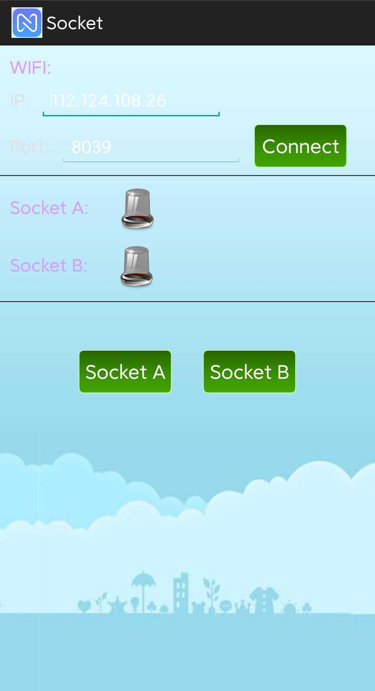

Widgets:

IP textbox, Port textbox: type in the IP of server and its port to be connected

Connect button: click to connect the aim server

Socket A/B buttons: click to control the power of sockets

Socket A/B views: indicate the power state of sockets

Behavior and state changes:



State transition diagram:



# Test Plan

## Test Design

### Test 1: Test voltages over major components

(Completed by Zhuocheng Hu)

1. Objective:

The objective of the test is to ensure voltages over the major components are in proper range when the system is running under different circumstances. The test helps avoid hardware damage to the sockets and the remote controller.

1. Setup:

Full system at working condition

1 multimeter

1. Procedure:

Correctly power the whole system. Switch the multimeter to voltage mode, connect the multimeter to the power supply pins of one of the following components: STM32, LoRa, and ESP8266. Disconnect the multimeter and repeat the steps for the other components.

1. Expected result:

The voltages over the major components should be within the following safe ranges:

LoRa SX1276 (E32-900T20D) working voltage:

Minimum: 2.3 V

Typical: 3.3 V

Maximum: 5.5 V

STM32f103C8T6 working voltage (through 5 V input pin):

Minimum: 4.7 V

Typical: 5 V

Maximum: 5.5 V

ESP8266 (ESP-01) working voltage:

Minimum: 3.0 V

Typical: 3.3 V

Maximum: 3.6V

### Test 2: Test LoRa communication range

(Completed by Yaoetng Tan, Zhengxuan Wen, Zhuocheng Hu)

1. Objective:

The objective of the test is to test the longest LoRa communication range possible to reach in the system under real-world circumstances.

1. Setup:

Full system at working condition

1 phone with GPS function and Internet connectivity

1. Procedure:

Correctly power the whole system at working states. Install antennas to the sockets and remote controller. Place two sockets in the living place of one team member and record the socket location. Assign one team member to take the remote controller and try to control the socket at different locations. Record the tested locations on the map using GPS. Analyze the data.

1. Expected results:

Per the datasheet of the LoRa module, the communication distance can reach 5.5 km. However, the communication distance will be affected when obstacles exist. We expect the range to be at least 3 km with no obstacles and at least 0.8 km with a moderate amount of obstacles. Considering the ideal test environment is hard to set up, we consider reaching a 1 km range within specification.

### Test 3: Test system algorithms and synchronization

(Completed by Yaoetng Tan, Zhengxuan Wen)

1. Objective:

The objective of the test is to test if the system can synchronize correctly after multiple different inputs of users to ensure the algorithms of the embedded software are correct. It checks if the system correctly reacts to users’ commands and if the remote controller, as well as the app, correctly indicates the status of the sockets.

1. Setup:

Full system at working conditions

Team members ready for control and visual inspection

Matlab

1. Procedure:

Correctly power the whole system at working states. According to the table, change the system to the desired current states and input the commands, 3 seconds apart from each command and inspect the status of the sockets, remote controller, and app.

| System initial status (socket A, socket B)  *For sockets: 1 = ON, 0 = OFF | Command  *1 = press button A on the remote controller, 2 = press button B on the remote controller, 3 = press button A on the app, 4 = press button B on the app |
| --- | --- |
| 0, 0 | In MATLAB  command = randi(4,1,100),  which generates an array of 100 numbers, each randomly selected from 1 to 4 |
| 0, 1 | In MATLAB  command = randi(4,1,100),  which generates an array of 100 numbers, each randomly selected from 1 to 4 |
| 1, 0 | In MATLAB  command = randi(4,1,100),  which generates an array of 100 numbers, each randomly selected from 1 to 4 |
| 1, 1 | In MATLAB  command = randi(4,1,100),  which generates an array of 100 numbers, each randomly selected from 1 to 4 |

1. Expected Results:

In every test case, and after each input command the system should correctly react according to the specification, the remote controller and the app should also report the correct status of the 2 sockets.

### Test 4: Test delay of the system

(Completed by Yaoetng Tan, Zhengxuan Wen, Zhuocheng Hu)

1. Objective:

The objective of the test is to determine how fast can different components react to the commands of users or states change of the other components. Lower delay will lead to a better user experience.

1. Setup:

Full system at working conditions

Sockets, remote controller, and phone with the app in the same house

Phone with good Internet connection

A timer

Team members ready for control and time the delay

1. Procedure:

Correctly power the whole system at working states. Press the button on the remote controller. Record the time from the button pressed to the LEDs on the remote controller changed state. Record the time from the button pressed to the socket changed state. Record the time from the button pressed to the status icon on the app changed state. Repeat the same procedure starting with pressing the button on the app. Repeat each test case 10 times and calculate the average response time.

1. Expected results:

The delay between the input of commands and output of status between the LoRa modules is expected to be under 300 ms in the tested distance. The input delay of the app (to turn on the sockets) is expected to be less than 150 ms and the output delay of the app (for the system reports status back to the app) is expected to be under 2000 ms.

### Test 5: Test system behavior under intensive commands

(Completed by Yaoetng Tan, Zhengxuan Wen)

1. Objective:

The objective of the test is to determine the behavior of the system under intensive user commands. For example, rapidly press the buttons in the app and remote controller at the same time. The test is more likely an experiment because the system is not designed for fast communication and irregular user behavior is not usual.

1. Setup:

Full system at working conditions

Timer

Team members ready for control

1. Procedure:

Correctly power the whole system at working states. Press the button on the remote controller at the frequency of 1 time/second for 3 seconds, inspect the socket status, the LEDs on the remote controller, and the icons in the app. Increase the frequency to 2 times/second, 3 times/second, and 5 times/second. Repeat the procedure with the app. Repeat the procedure with the remote controller at the same time. Finally, repeat the experiments 10 times and record the estimated input commands interval and record the behavior of the system.

1. Expected results:

Ideally, the system should always synchronize no matter how fast the users input the commands. However, the system is not designed for fast communication under 100 ms, so desynchronization may occur in our system.

## Bug Tracking

| Bug | People in charge | Solution |
| --- | --- | --- |
| STM32 in socketA didn’t have power. | Zhuocheng Hu | Checked the soldering of the PCB. Found one of the STM32 pins to be desoldered. Re-soldered the pin, and problem solved. |
| The remote controller periodically powered off during the tests. | Zhengxuan Wen  Yaoteng Tan | Codes verified to be correct. The issue was found to be due to the protection feature of the power bank. Switched the power supply to be the USB port of a laptop. The issue no longer appeared. |
| The system was out of synchronization during test 5. | Yaoteng Tan  Zhengxuan Wen | Verified the correctness of the algorithm. The reason was found to be the limitation of the hardware. Possible solutions are given in the test report. |

## Quality Control

| Test | Date | Description |
| --- | --- | --- |
| Test 1: Test voltages over major components | March 6, 2022 | Failed. No power for STM32 in socketA. |
| March 6, 2022 | Passed. Bug fixed. |
| Test 2: Test LoRa communication range | March 6, 2022 | Passed |
| Test 3: Test system algorithms and synchronization | March 7, 2022 | Failed. The remote controller periodically powered off during the tests. |
| March 7, 2022 | Passed. Bug fixed. |
| Test 4: Test delay of the system | March 7, 2022 | Passed. |
| Test 5: Test system behavior under intensive commands | March 7, 2022 | Failed. Cause of the bug detected. Possible solutions provided in the test report. |

## Identification of critical components

Describe the components that are critical and demand particular attention during testing are identified.

* STM32:
  + Central processing unit
* SX1276 LoRa module
  + Critical communication module for remote control
* ESP8266 Wi-Fi module
  + Critical communication module for Internet control
* Transformer and relay
  + Critical power supply parts
  + Using high voltage AC power source

## Items Not Tested by the Experiments

* Have not tested the functionality of the system under a busy and complex signal environment
  + Hard to simulate such an environment

# Test Report

## Test 1: Test voltages over major components

(Completed by Zhuocheng Hu)

1. Test results:

| Components | Minimum voltage (V) | Maximum voltage (V) |
| --- | --- | --- |
| STM32 in socket A | 4.95 | 5.05 |
| STM32 in socket B | 4.89 | 5.01 |
| STM32 in remote controller | 4.93 | 4.99 |
| LoRa in socket A | 4.83 | 4.91 |
| LoRa in socket B | 4.91 | 5.03 |
| LoRa in remote controller | 5.01 | 5.06 |
| ESP8266 in socket A | 3.29 | 3.37 |
| ESP8266 in socket B | 3.25 | 3.33 |

1. Comparison with the expected results:

| Components | Percentage error comparing to typical values | In working voltage range (Yes/No) |
| --- | --- | --- |
| STM32 in socket A | -0.1% ~ 1.0% | Yes |
| STM32 in socket B | -2.2% ~ 0.2% | Yes |
| STM32 in remote controller | -1.4% ~ -0.2% | Yes |
| LoRa in socket A | -3.4% ~ -1.8% | Yes |
| LoRa in socket B | -1.8% ~ 0.6% | Yes |
| LoRa in remote controller | 0.2% ~ 1.2% | Yes |
| ESP8266 in socket A | -0.3% ~ 2.1% | Yes |
| ESP8266 in socket B | -1.5% ~ 0.9% | Yes |

1. Analysis of test results:

The test results accord well with the expected results. The largest percentage error of voltages in the data is only -3.4%, and all of the components are in their working voltage ranges. The results show all of the major components work at optimal voltages when the system is running under different circumstances.

1. Corrective actions taken:

N/A. All major components are working within ideal voltages.

## Test 2: Test LoRa communication range

(Completed by Yaoetng Tan, Zhengxuan Wen, Zhuocheng Hu)

1. Test results:

In the picture below, the blue point represents the socket location while the red marks represent the locations tested in Test 2

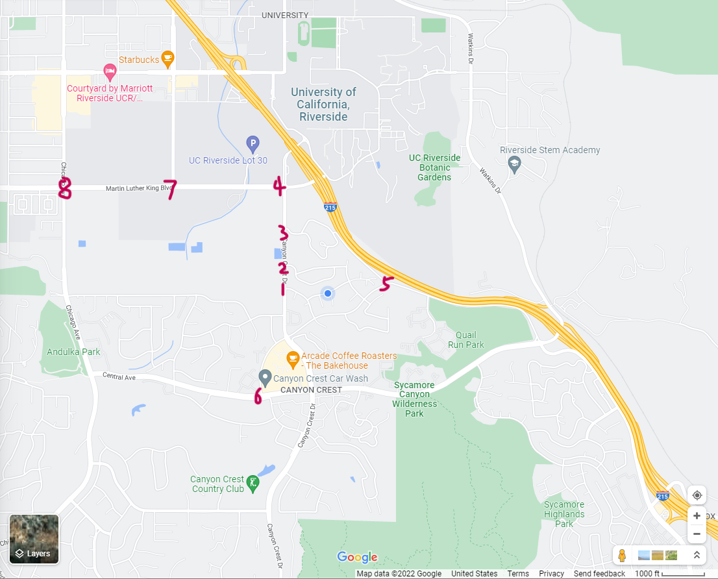

| Location # | Distance (km) | Controllability (Yes/No) |
| --- | --- | --- |
| 1 | 0.31 | Yes |
| 2 | 0.36 | Yes |
| 3 | 0.56 | Yes |
| 4 | 0.82 | Yes |
| 5 | 0.44 | Yes |
| 6 | 0.90 | Yes |
| 7 | 1.36 | Yes |
| 8 | 2.04 | No |

Comparison with expected results:

In general, the test results meet the specifications of the expected results.

1. Analysis of test results:

The test condition can be considered as communication with a moderate amount of obstacles since there are houses and trees blocking the communication. From the data, the communication successfully reaches a distance of 1.36 km which exceeds the expectation of 0.8 km. Although the results are still far from the ideal ranges in the datasheet, the range achieved is generally sufficient for personal users and small businesses. Yet, improvement may be needed for large-scale industrial users.

1. Corrective actions taken:

N/A. We find the current setup is the best for our objectives and it meets our expected specifications. Achieving longer ranges either requires larger antennas or requires other hardware, such as signal amplifiers. These modifications do not conform with the design objective of a compact system.

## Test 3: Test system algorithms and synchronization

(Completed by Yaoetng Tan, Zhengxuan Wen)

1. Test results:

| System initial states (socket A, socket B)  *For sockets: 1 = ON, 0 = OFF | Command  *1 = press button A on the remote controller, 2 = press button B on the remote controller, 3 = press button A on the app, 4 = press button B on the app |
| --- | --- |
| 0,0 | 2 4 4 2 2 3 3 1 1 1 1 2 3 4 3 4 1 3 4 2 4 4 1 3 1 1 2 2 2 2 2 3 4 1 2 3 4 4 3 1 3 4 1 2 2 2 2 4 1 1 4 3 2 2 3 3 3 4 1 2 1 3 4 3 1 1 4 1 4 2 2 1 4 2 2 2 2 2 3 3 1 1 2 4 4 3 2 4 2 1 3 4 4 4 4 3 4 4 3 4 |
| 0,1 | 4 4 2 4 4 4 4 2 4 4 2 1 4 3 4 2 2 3 4 3 2 2 2 1 3 4 3 2 4 4 4 3 3 2 3 4 2 3 2 3 1 1 1 3 4 4 3 1 3 4 4 2 2 1 3 3 1 2 2 4 4 3 1 3 3 2 1 2 4 2 4 3 4 4 3 3 3 1 4 4 3 2 2 1 3 3 3 1 1 2 2 4 4 4 1 1 3 3 3 2 |
| 1,0 | 2 2 1 1 3 2 4 3 3 3 4 2 4 4 4 1 2 2 3 1 2 4 2 1 4 3 1 2 3 3 2 3 1 4 4 2 4 2 3 1 3 3 1 1 2 2 4 1 4 1 2 2 4 1 4 3 2 4 3 2 4 2 4 3 4 3 1 4 4 1 3 2 3 2 4 3 3 1 2 2 4 4 3 4 4 3 4 2 2 1 4 2 4 4 2 2 1 4 3 2 |
| 1,1 | 4 3 3 3 4 1 2 2 1 1 4 1 4 3 1 1 4 2 4 1 4 1 4 4 3 4 3 4 3 1 4 3 4 2 1 3 2 1 4 3 4 2 4 4 2 4 2 1 2 1 1 3 3 3 3 4 1 3 3 3 4 2 1 2 4 2 2 1 2 3 4 3 3 4 2 2 2 3 2 2 3 4 4 4 3 2 1 1 3 4 3 4 1 3 2 1 4 2 1 4 |
| Number of total commands tested | 400 |
| Accuracy | 100% |

1. Comparison with expected results:

The test results meet the expectation very well. In every test case, and after each input command, the system correctly reacts according to the specification; the remote controller and the app also report the correct status of the 2 sockets.

1. Analysis of test results:

In this test, we tested 400 commands under different system initial states, which is a considerably large sample. The system is able to achieve an accuracy of 100% after different test cases. The test indicates there are no major flaws in the algorithm of the embedded software and the app software.

1. Corrective actions taken:

N/A. No fix is needed. However, if there is sufficient time, it will be better to design automated tests and enlarge the test samples.

## Test 4: Test delay of the system

(Completed by Yaoetng Tan, Zhengxuan Wen, Zhuocheng Hu)

1. Test results:

| Item | Average delay (ms) |
| --- | --- |
| Delay between the input of commands and output of status between the LoRa modules | < 250 ms (Almost instant, too fast to manually measure) |
| The input delay of the app to turn on the sockets | < 250 ms (Almost instant, too fast to manually measure) |
| Output delay for the system reports status back to the app | 2135 ms |

1. Comparison with expected results:

In general, the test results meet the expectation, except the output delay for the system reports status back to the app is a little bit out of range.

1. Analysis of test results:

From the data in the table, we can see that the communication between the LoRa modules is robust and fast. Although the input delay of the app to turn on the sockets is ideal, the Output delay for the system reports status back to the app is slow. However, the delay is expected by design that the ESP8266 is coded to send data every 2 seconds to the server to avoid errors through TCP connection to the server.

1. Corrective connections taken:

N/A. Future improvements may include a more stable server to decrease delay.

## Test 5: Test system behavior under intensive commands

(Completed by Yaoetng Tan, Zhengxuan Wen)

1. Test results:

| User behavior | Interval between commands (ms) | System behavior |
| --- | --- | --- |
| Pressing buttons on the remote controller rapidly | 1000 | Normal |
| 500 | Normal |
| 333 | Normal |
| 200 | LEDs on the remote controller desynchronize at a probability of 50% |
| Pressing buttons on the app rapidly | 1000 | Normal |
| 500 | Normal |
| 333 | Normal |
| 333 | Normal |
| Pressing buttons both on the remote controller and the app rapidly | 1000 | Normal |
| 500 | Normal |
| 333 | Normal |
| 200 | LEDs on the remote controller desynchronize at a probability of 60% |

* System will return to normal when users return to normal behavior.

1. Comparison with expected results:

As expected, the system has a chance of desynchronizing under intensive commands.

1. Analysis of test results:

As mentioned before, the system is not designed for fast communication under 300 ms, so desynchronization occurs as expected. From the test, we can see that desynchronization begins to happen when the interval between command decrease to under 200 ms. We find that the system is desynchronized because the SX1276 LoRa module only works in half-duplex mode, which means it can both send and receive signals, but not simultaneously. Therefore, some of the data may be ignored and lost when LoRa modules are sending and receiving data at the same time. It also explains the fact that when only using the app to input commands, the system is always in synchronization because, under this circumstance, the LoRa module in the socket is only sending while the LoRa module in the remote controller is only receiving. In comparison, the ESP8266 module works in the full-duplex mode, which ensures robust and stable communication. As a result, the app is always synchronized during the entire test.

1. Corrective actions taken:

N/A. There is not enough time to fix this issue. However, there are some possible solutions. The first solution by only using current components is to add 1 extra LoRa module to each socket and remote controller so that each LoRa module is dedicated to either sending or receiving. As a result, the socket and the remote controller can be “full-duplex.” Another possible solution is to use more advanced LoRa modules with the full-duplex mode, such as Semtech LoRa Corecell Reference Design modules. Yet, these modules are merely available for individual buyers on the market.

# Conclusion and Future Work

## Conclusion

To conclude, the outcome of the project is satisfying; yet, there are still improvements that can be made, and features can be added to the system. After the verification and validation, it can be confirmed that the finished work meets the overall goals and quantitative technical design objectives. The system incorporates many areas of electrical engineering, such as circuit designs, embedded systems, and software development. Great time and efforts have been contributed to the project to ensure the proper coordination of the various modules.

In the project, responsibilities of the work follow as below*:

Zhuocheng Hu - hardware design and development, server research and development

Yaoteng Tan - software development of remote controller(STM32, LoRa), Android app used for connectivity

Zhengxuan Wen - software development of sockets (STM32, LoRa, ESP8266), system integration

*Other work are done as joint-work of all three members

All of the team members successfully achieve the majority of the goals and objectives. Nevertheless, the system can improve and have more added features through teamwork if there is more development time. There are several flaws detected in the system. The first issue is that the LEDs on the remote controller may indicate the wrong status of the sockets if the users send the input command too rapidly. For example, clicking the buttons on the remote controller 5 times in 1 second may cause the LEDs to indicate the wrong status. Meanwhile, the status icon on the app works fine; also, the system would correct itself as soon as the users return normal input behavior. The flaw is found to be caused by the LoRa module because it has limited bandwidth and can not receive and send data at the same time. Another feature that is not achieved is the ability to paring extra sockets. It is due to the limited time frame and the possible necessity to modify the hardware. The setbacks teach us to consider technical solutions more thoroughly and manage time more efficiently.

Below are the thoughts of each team member:

Zhuocheng Hu

This is the first project where I am fully involved in all steps, including discussions of design, hardware design, and software design. I consider this project as the gateway to the working environment in the real world, which will be very helpful when I actually work in the future. Therefore, I personally have a high expectation about this project, and I believe I got what I want to get through the project. Before this project, I learned welding myself and was able to solder SMD ICs to the PCB board. Also, I learned Altium designer software for designing PCB through video and books. I consider the class EE 120B provided a good beginning of coding embedded systems for a beginner like me. Although I already have a strong background, I still learned a lot from this project. As the plan progressed, our team got a hard time debugging our code into our PCB, and we spent a short time changing our plans, and redesigning the PCB, and finally got over the problems we met. Overall, I believe I have become more professional and understand how to make a product from scratch. In addition, teamwork taught me that it is impossible to do a project alone in a short time, and communication is very important for every engineer.

Yaoteng Tan

This project develops my abilities to solve problems independently and efficiently. For example, learning the usage of electronic modules through examples that I have never used before; resolving questions about the unfamiliar hardware by looking at its datasheet and manual. Before the senior design project, I used to learn things from scratch before applying them to practical use, which was time and effort consuming.

Zhengxuan Wen

Through the project, I learned a lot in terms of technical knowledge and skills as well as professional and personal growth. The project is one of the most large-scale projects in my undergraduate study. I have learned about many different branches of electrical engineering. My main responsibility was to program the embedded system in the project, including the STM32, LoRa, and ESP8266. The experience extended my knowledge of the embedded system from my previous CS 120B class. First of all, I learned about new MCUs from scratch. I had to research documents such as datasheets, make small programs for practice, program the final system, and debug. The systematic jobs certainly gave me a clearer view of how engineers develop new products. Also, for the first time, I learned to use the professional and industrial development platform - Keil. It was much different from the tools I previously used, such as Arduino. I had to build the proper development environment for the specific MCUs, configure proper libraries for different functions. The process made me learn a lot about embedded programming. Furthermore, I learned a lot through teamwork from my team members. Since we had to collaborate to develop the system, I also learned some about hardware designs and app development. Therefore, I had a chance to learn other branches of electrical engineering that I was not so familiar with. Thankfully, we collaborated well through great communication and helping each other. Working as a team taught me the importance of communication and teamwork as an engineer.

## Future Work

Many improvements can be made and many features can be added to the system. First of all, the issues presented in the system must be fixed. The solution may include using more advanced LoRa modules or adding extra LoRa modules to the system. The next is adding extra features to the systems. These features may include but are not limited to pairing with other hardware, integration with AI, automation tasks, etc. By these steps, the marketability of the system will be greatly improved.

## Acknowledgement

Dr. Roman Chomko

* Faculty advisor
* Reviews and supervises project
* Offers technical advice

Cody Simons

* Section teaching assistant
* Reviews and supervises project
* Offers technical advice and helps

Manglai Zhou

* Research & development engineer
* Offers advice on PCBs and hardware designs

Gang Zhao

* Provides the use of Alibaba cloud.

All previous professors and teaching assistants

* Provide necessary knowledge

# References

“Advanced AMS1117 monolithic 1A low ... - advanced monolithic,” *Advanced Monolithic Systems*. [Online]. Available: http://www.advanced-monolithic.com/pdf/ds1117.pdf. [Accessed: 09-Mar-2022].

“E31-433T17D User Manual - Ebyte.com,” *Chengdu Ebyte Electronic Technology*. [Online]. Available: https://www.ebyte.com/en/downpdf.aspx?id=144. [Accessed: 08-Mar-2022].

“ESP-01 WIFI module - microchip.” [Online]. Available: https://www.microchip.ua/wireless/esp01.pdf. [Accessed: 09-Mar-2022].

“Medium-density performance line arm ... - stmicroelectronics,” *Medium-density performance line ARM®-based 32-bit MCU with 64 or 128 KB Flash, USB, CAN, 7 timers, 2 ADCs, 9 com. interfaces*, Aug-2015. [Online]. Available: https://www.st.com/resource/en/datasheet/stm32f103cb.pdf. [Accessed: 08-Mar-2022].

“MDK5 software packs - keil,” *STM32F1 Lib*, 10-Dec-2021. [Online]. Available: https://www.keil.com/dd2/pack/#!%23eula-container. [Accessed: 08-Mar-2022].

“Relay ISO9002 1. main features - circuit basics,” *SONGLE RELAY*. [Online]. Available: https://www.circuitbasics.com/wp-content/uploads/2015/11/SRD-05VDC-SL-C-Datasheet.pdf. [Accessed: 09-Mar-2022].

# Appendices

Presents information that supplements the design specification, including:

**\* Appendix A:** Parts List

* STM32F103C8T6
* E32-900T20D LoRa SX1276
* ESP8266 Wi-Fi Module
* Double-Sided Prototype(PCB)
* Red LED
* On/Off Switch
* Button Switch
* SRD-05VDC-SL-C Power Relay
* AC to DC Converter
* AMS 1117 Linear Regulator
* Bipolar (BJT) Transistor PNP
* 220Ω Resistor
* 10kΩ Resistor
* 0.1µF Capacitor
* 220 µF Capacitor
* AC Power Cord
* Socket with Cable

**\* Appendix B:** Equipment List

* Soldering Iron
* Wire Cutter
* Multimeter
* Tape

**\* Appendix C:** Software List

* Altium Designer System Engineering (SE)
  + https://www.altium.com/
* Keil MDK-ARM Version 5
  + https://www.keil.com/demo/eval/arm.htm
* Eclipse IDE for Java EE Developers
  + https://www.eclipse.org/downloads/packages/release/luna/sr2/eclipse-ide-java-ee-developers

**Appendix D:** Special Resources

* N/A

**Appendix E:** User's Manual - If your design requires instructions for future use, here is the place to put that information.

1. Plug in the socket.
2. Use a battery or power bank to power up the remote controller.
3. Download the Android application.
4. On the remote controller, press buttons to turn on/off the socket. The red LED will turn on when the socket is On, and the red LED will turn off when the socket is Off.
5. On the Android application, press the socketA/B buttons to turn on/off the socketA/B. The state icon will be on when the socket is On, and the state icon will be off when the socket is Off.

**Appendix F：** Features to add in the future

* Pairing system
  + If one of the sockets is broken and we hope can replace it with a new one. There need a pairing and unpairing system.
  + We expect no hardware design for the pairing system by using the existing button on the socket and the button on the remote controller. Possible solution:
    - Ex. Add new buttons and LEDs. Hold the button for 5 sec to enter the paring mode, and the red LED will flash when it successfully enters the pairing mode.
* Factory Reset
  + If the system crashes, we hope to have a function to reset the system.
  + We expect no hardware design for the factory reset by using the existing button on the socket and the button on the remote controller. Possible solution:
    - Ex. Add new buttons and LEDs. Hold the button for 10 sec to factory reset, and the red LED will flash when it successfully factory reset.

**Appendix G：** Project files: <https://drive.google.com/file/d/1cgqWqAoYAcr8BSKkAI846T3_Bw4mBusf/view?usp=sharing>